**Test Report: Test Site Hotfire 4.1**

**Test Protocol**

| **System** | Propulsion & Launch Systems (Thrust Chamber, Test Site) |
| --- | --- |
| **Subsystem** | Engine (i.e. combustion chamber, tank, injector, fuel, igniter), DAQ |
| **Personnel and Specifications** | [*5 trained test site operators, 5+ road blockades to maintain security perimeter, 1+ dedicated media person is recommended]*   | **Date [yyyy/mm/dd]** | Test Date: 2025/06/07  Report last Updated: 2025/06/24 | | --- | --- | | **Location** | [MRT test site, *McGill - MacDonald Campus,*  *Saint-Anne-de-Bellevue*] | | **Ambient conditions** | [*~ 20°C, Night*] |  * Original test site specifications can be found in the [test site user and design guide](https://drive.google.com/file/d/1T0_7gnqkVZIek44ZBNnr2altFaNHVAi0/view?usp=drive_link) submitted to Launch Canada for hot fire approval * Updated P&ID can be found [here](https://drive.google.com/file/d/1xTVoo6o4SbPMxHkfyndwszhy6sDIqb-k/view?usp=sharing) |
| **Type** | Validate engine performance using the new nozzle and composite spacers. (and originally, mold casted fuel as well) |
| **Purpose** | *The purpose of this test was to validate the use of Maelstrom Mk.IV and obtain performance metrics.* |
| **Requirements** | Notify MacDonald campus security (possibility of hotfire after), follow all [procedures](https://docs.google.com/document/d/122wGlMerqRpMMDwgtA3S-afYfmZPPRNJJ68194ijSAI/edit?tab=t.0) and safety precautions |
| **Setup** | * Refer to the [test site user and design guide](https://drive.google.com/file/d/1T0_7gnqkVZIek44ZBNnr2altFaNHVAi0/view?usp=drive_link) (slightly outdated) and to the [procedures](https://docs.google.com/document/d/122wGlMerqRpMMDwgtA3S-afYfmZPPRNJJ68194ijSAI/edit?tab=t.0) for details on the setup |
| **Materials and equipment** | * Refer to the [test site user and design guide](https://drive.google.com/file/d/1T0_7gnqkVZIek44ZBNnr2altFaNHVAi0/view?usp=drive_link) and to the [procedures](https://docs.google.com/document/d/122wGlMerqRpMMDwgtA3S-afYfmZPPRNJJ68194ijSAI/edit?tab=t.0) for a full list of materials and equipment required |
| **Procedure** | * Refer to the [procedures](https://docs.google.com/document/d/122wGlMerqRpMMDwgtA3S-afYfmZPPRNJJ68194ijSAI/edit?tab=t.0) for step by step instructions |
| **Safety** | Refer to Appendices of the [test site user and design guide](https://drive.google.com/file/d/1T0_7gnqkVZIek44ZBNnr2altFaNHVAi0/view?usp=drive_link). |

**Test Results**

Pre-Test Timeline:

* Friday, June 6th:
  + While assembling the engine, it was noticed that the molded fuel wiggled a lot inside of the liner. Further inspection showed that the clearance was significant (~1cm), which raised some concerns: mainly, the risk at engine start-up that the difference in pressure between the inside and the outside of the fuel would be too large and would cause it to shatter, since it would not be perfectly supported by the liner.   
    This had not been noticed before (including at the second assembly test on May 17). All fuels had been made in March, and had been transported to the test site at least once on a previous hotfire trial. Thus, it is possible that molded fuels either shrink during curing (in which case that loose fit was not found by negligence), or continuously shrink over time (which does not seem to be the case with spincasted fuel grains).
  + It was thus decided to spincast a new fuel in an emergency. Thankfully, all necessary materials and equipment were properly conserved, and well-written SOPs ([Spin Casting SOP.docx](https://docs.google.com/document/d/1O9JjI-vo8vL63Ak2msI5-t9yaLa0SIXV/edit)) made the process relatively easy to follow.
  + A first fuel was finished that night, but significant leakage at the long plug interface made the fuel noticeably underweight at 1.439 kg (VS the target mass of 1.878 kg). Additionally, it was noticed that the fuel still did not fully feel rigid, and seemed still slightly malleable. Bits of fuel stuck to a plug, which created a “cone” shape at the entrance.   
    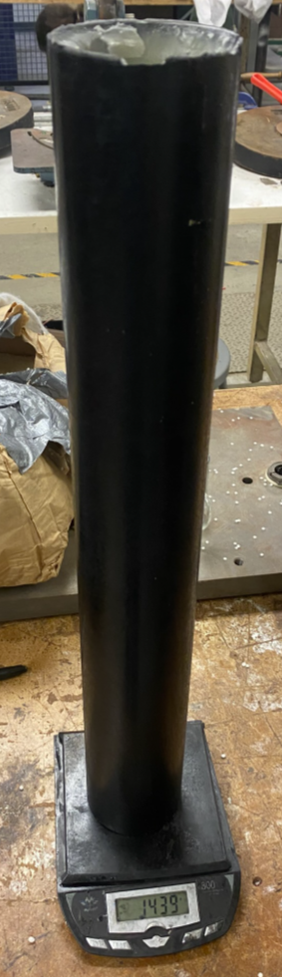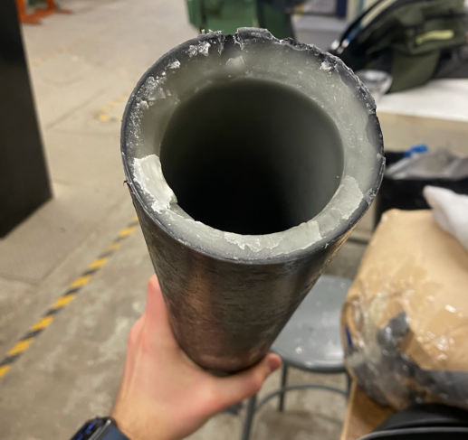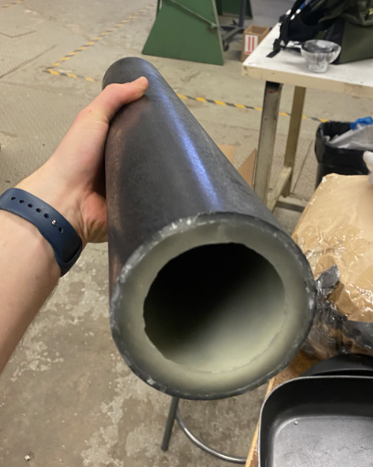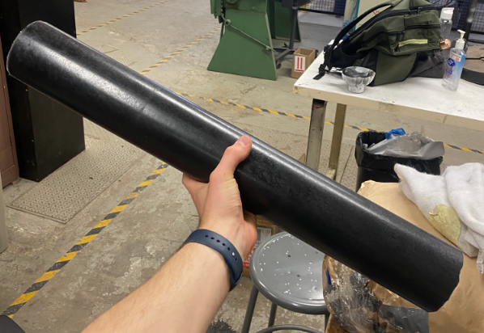
  + A second attempt was started right after. The leakage was tried to be resolved by adding a second o-ring to the plug, as well as by adding a second 3D printed support ring (which was broken, but would act as an additional support to the o-rings). Spincasting was finished at 3am, and due to the “curing” issue observed below (as well as need for sleep), the fuel was left in the casing for the rest of the “night”.
* Saturday, June 7th:
  + Starting at 7:30am, attempts were made to un-mold the spincasted fuel grain. However, it proved to be a tricky endeavour as one of the plugs got stuck after being unthreaded. Efforts to pull it out by clamping it to a vice and pulling were unsuccessful despite up to 4 people’s efforts at the same time.   
    Modern problems require modern solutions, and if Men could not defeat the Machine, then perhaps only a Machine could defeat the Machine. A jig was assembled to press on the lip of the plug using the workshop’s press, while resting on an assemblage of weights and steel bars. This eventually proved to be successful, and the plug was removed after around 3 hours of effort from the start of unmolding.
  + Unfortunately, that second fuel was even more underweight, at ~1.3kg. This was also due to significant leakage through the long plug. It was also determined that the plug was stuck most probably due to a combination of the 3D printed ring being press-fitted, and solidified fuel in between that and the liner.
  + It was then decided to pursue two methods in parallel: to spincast another fuel grain but by accounting for the leakage (adding more paraffin than usual), and to try to add an outer layer to an existing mold-casted fuel grain.
  + It was later decided to not use the top-up mold casted fuel grain, as it was uncertain how much the outer layers would adhere to the original cast.
  + Unfortunately, the new spin-casted fuel slightly broke off at one end, making it ~23 inches short for a mass of ~1.5 kg.
  + Ultimately, as none of the spincasted fuel grains were very very close to the target mass of 1.878kg, it was decided to hotfire the 1.439 kg spincasted one to keep the same spacer dimensions as before.
  + A first group went to the test site early to prepare for the test. Once the second group came back with the engine parts and fuel grains, making the final preparing steps was quick. Procedures occurred nominally and quickly, which resulted in the hotfire taking place at around 11pm.

**Hotfire Data**

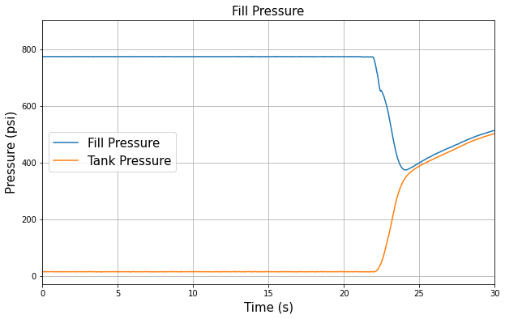

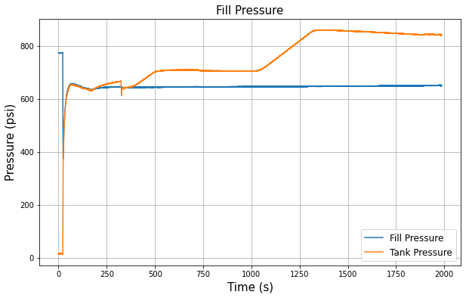

Note: the dip at t=~300s corresponds to a second filling attempt (as expected, no further mass increase was possible). Heating the tank was quick, up to a maximal value of 860 psi. The tank was first heated for a couple seconds, after which an issue with the purge pressure was encountered (see below). The heating blankets where turned off while the issue was being figured out, and then heating resumed (seen by the second, larger increase in tank pressure).

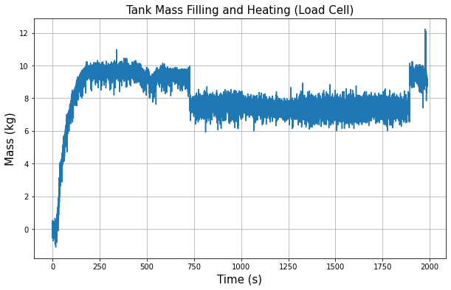

Note: the section from 730 to 1850 is when the heating blankets were in use, and might have interfered with the mass measurement. Filling was confirmed by seeing a plume out of the vent tube. Further filling was attempted out of curiosity, and as expected it was not possible to fill more.

The estimated oxidizer mass was 9 kg to 9.75 kg.

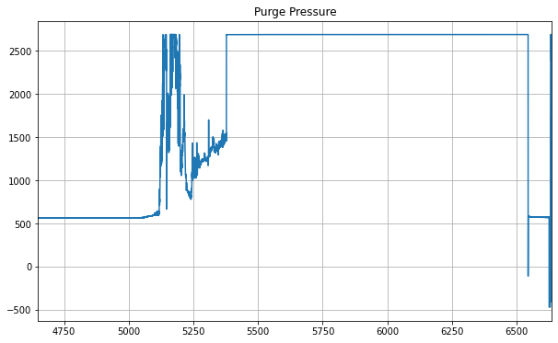

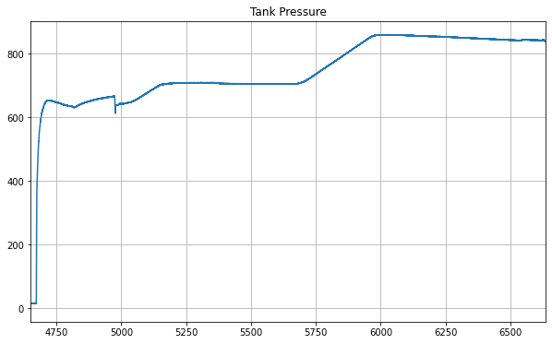

Tank pressure (absolute time)

Note: the “purge” pressure transducer (in reality, corresponds to the nitrogen line pressure, before the purge valve) started to show a drastic increase of pressure very rapidly during heating.

On the instant, the main concern was that the heating would affect the nitrogen; however, this would not be possible since the purge valve was still closed at that time, and thus the only way for heat to be transmitted would be via the tubing, which would not result in such a sharp increase.

Secondly, a pressure regulator failure was theorized. However, the increase was so drastic but with no leaks seen from the gas cage that this option was discarded. Additionally, the pressure inside the gas bottle had been previously measured at 2,500 psi, which is lower than the maximal reading of the pressure transducer at 2,800 psi - thus making this overpressurization not physically possible.

Thus, an electrical issue was deemed as the most likely problem with the readings. It is possible that the heating blankets affected the voltage reading of the sensor, potentially as a result of improper separation of the different power lines which affected each other. This is confirmed by comparing the times at which the irregularities were shown, to when the heating blankets were on (by comparing the absolute test time of both graphs above).

Additionally, a 900 psi pressure relief valve was installed on the nitrogen line, specifically to prevent such overpressurizations. Even if the incoming flow would be greater than the exhaust capacity, the vented nitrogen would be observed as vibrating the exhaust tube on the outside.

Finally, a last sanity check was run by verifying the pressure reading on the purge pressure regulator R13. While the numbers could not be read, the operators remembered the maximal reading of the gauge and as such the pressure could be estimated, and seemed to be normal. It was thus decided to completely ignore the purge pressure transducer readings for the rest of the test due to this abnormal phenomenon, and instead rely on the pressure gauge seen on the Ubiquity camera.

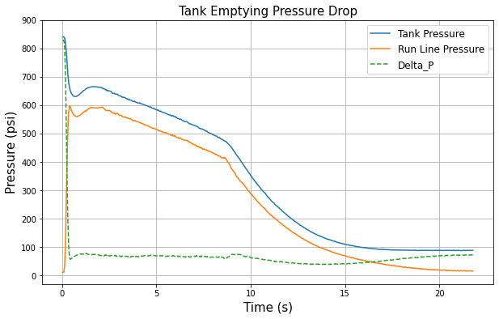

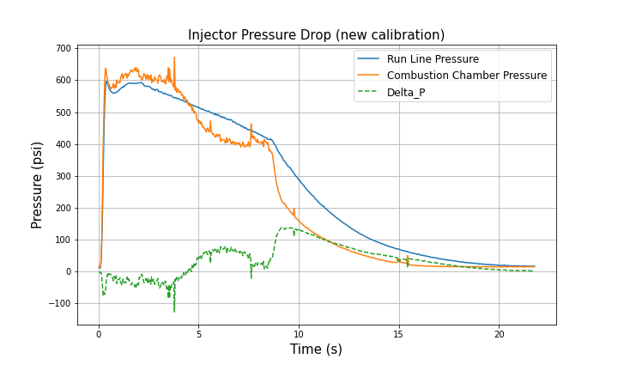

Note: the results of this graph are indeed worrisome, as a negative delta P is usually a sign of backflow, especially over a span of 4 seconds. However, from the camera views as well as the lack of soot in the run line, it appears that this was not the case. The injector pressure drop only goes back to a nominal state at about 9 seconds into the burn (compared to previous hotfires). It is possible that the diffuser (located right before the injector) changes the pressure of the running fluid and thus might explain the lack of backflow, however this would be complicated to compute in the context of two-phase flow. Another theory is that the transient pressures that are measured are not exactly accurate, as the flow passing at high velocity would "suction" at the pressure port location (which are located perpendicular to the flow). However, given that this is how all previous tests were measured, this data still remains highly off-nominal.

Reasons for this phenomenon are discussed in the following sections of the report.

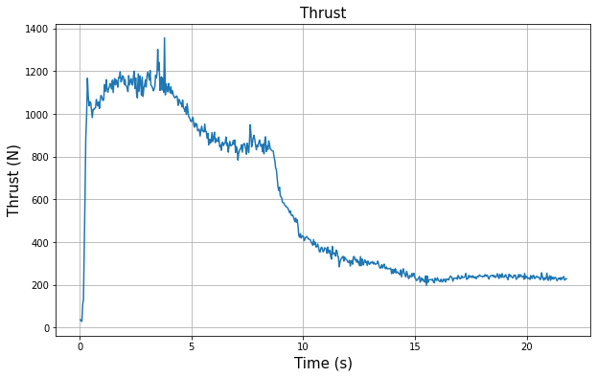

Note: thrust values might not be properly calibrated.

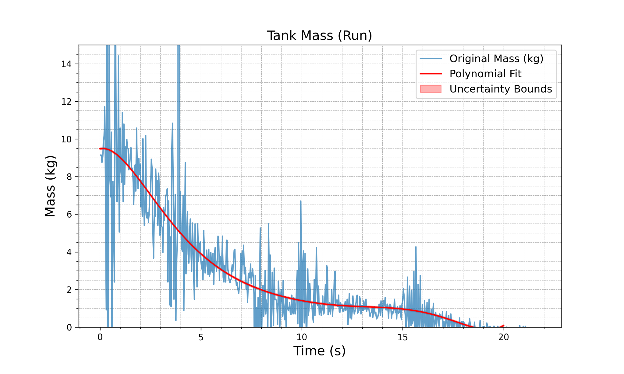

Note: the mass data was fitted manually. Anthony Côté (Propulsion Subteam Lead, 2022-23) recommended to try to use a Savitzky-Golay filter on this sort of noisy data.

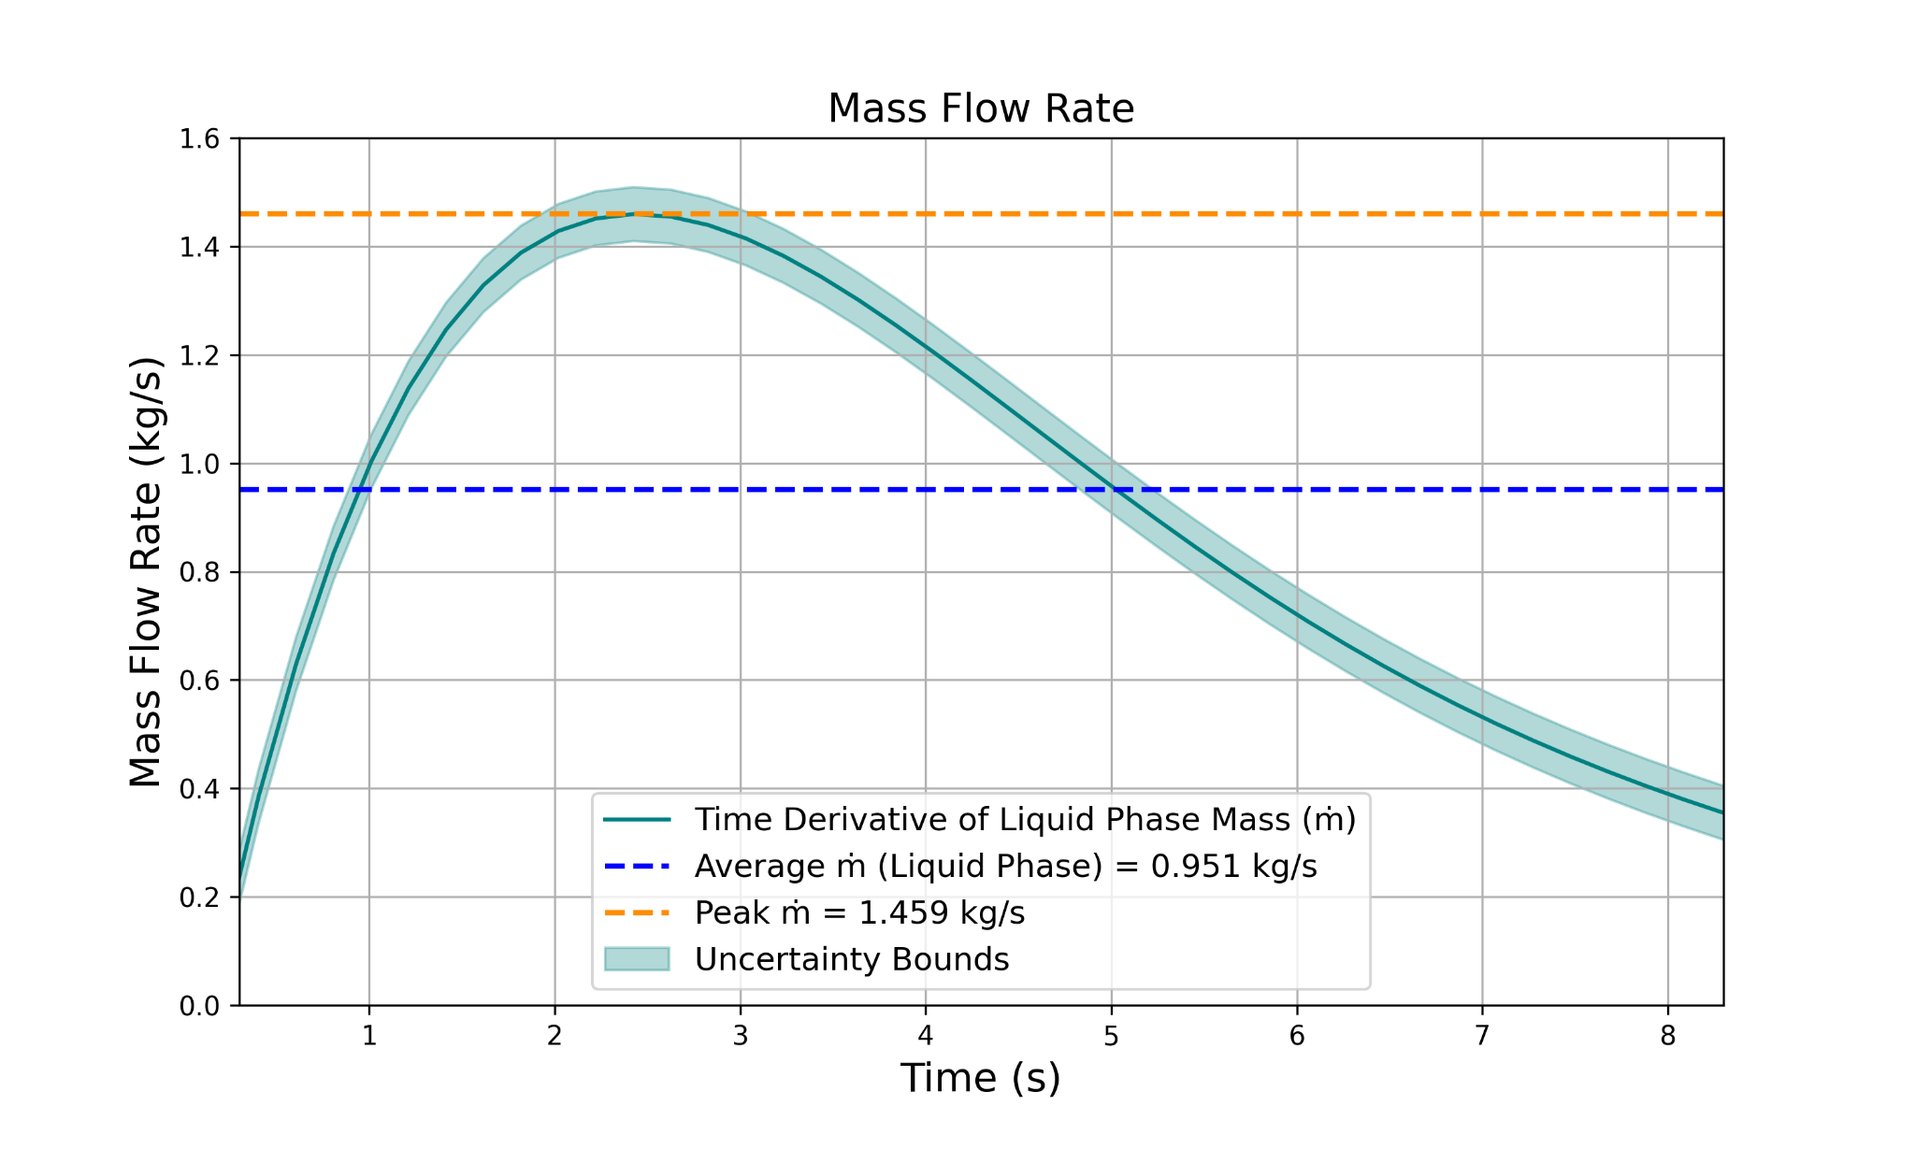

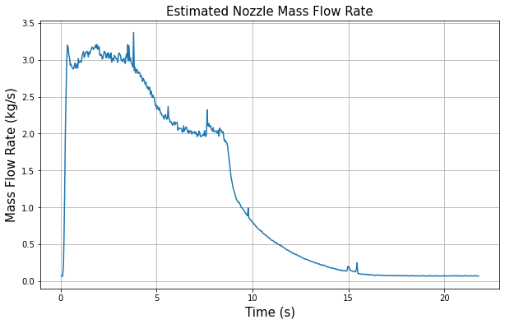

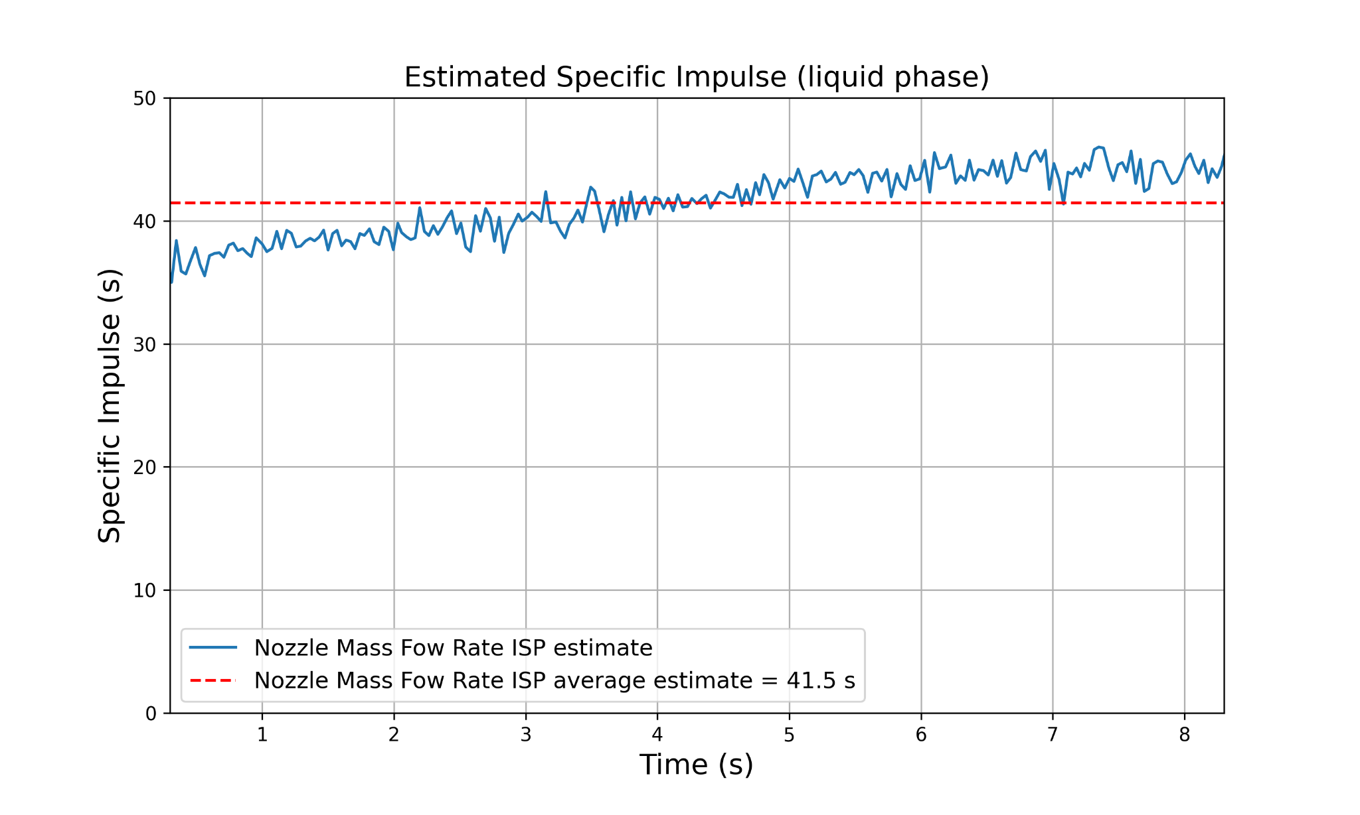

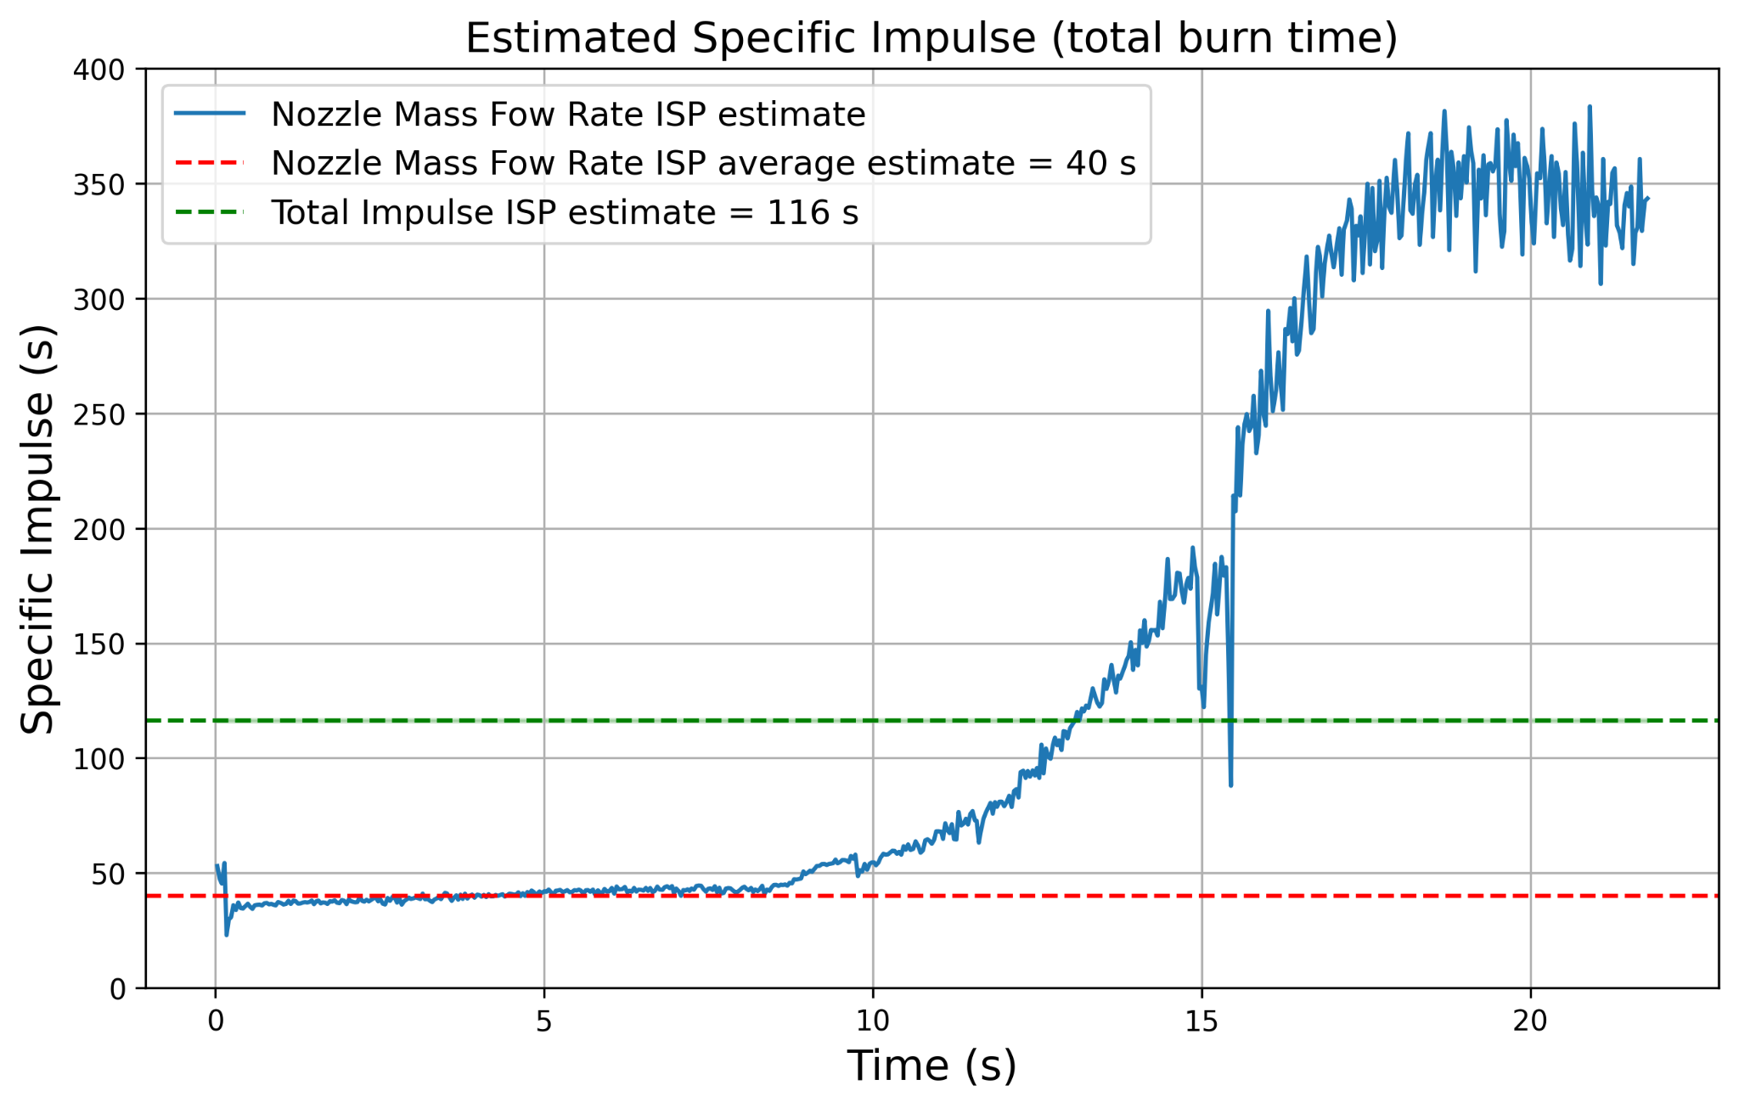

Note: the total ISP is strongly skewed by the end of the burn, which seems to shoot up to a value of 370s. This is unheard of in hybrid rocket engines (for comparison, *Maelstrom* usually has an ISP of over 200s during the liquid blowdown, and only Hydrolox engines can reach such high values, usually up to 450s). The reason for these absurd values at the end of the burn are the low oxidizer mass flow rate, medium thrust (there seems to be a constant hysteresis of 220 N at the end of the burn - phenomenon consistent with previous hotfire data), as well as the liner burning a bit and potentially producing a bit of extra thrust (and thus cheaping the propellant mass flow rate values). As such, only the liquid blowdown ISP values are relevant.

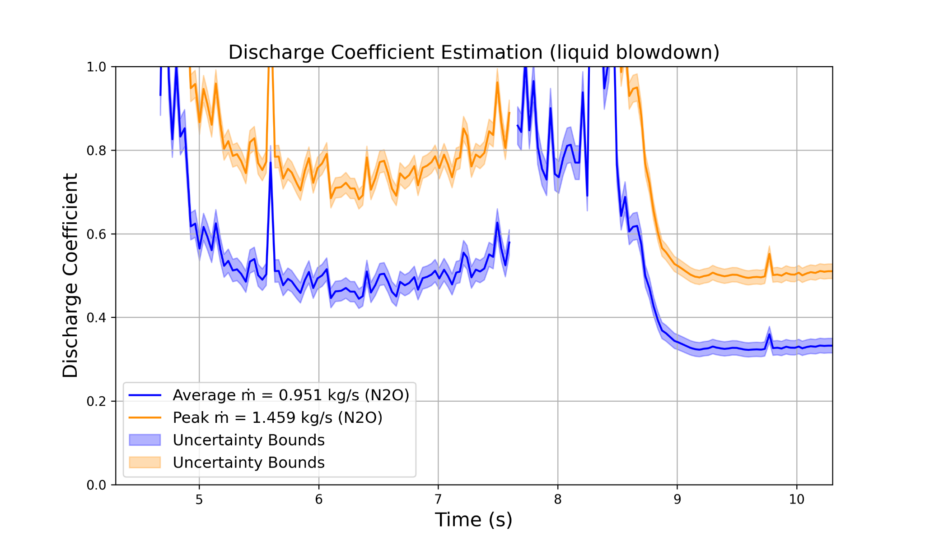

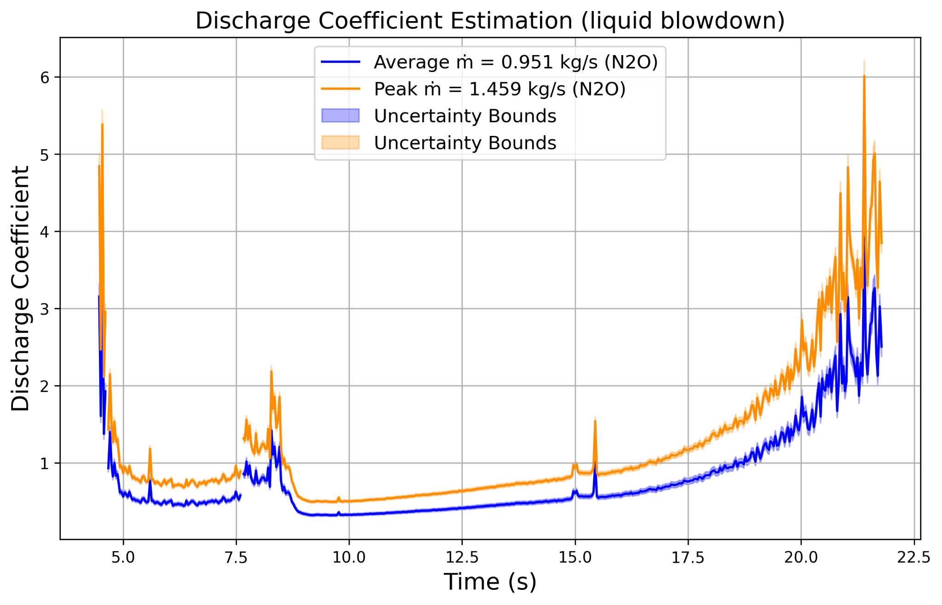

Note: similarly, the discharge coefficient is severely distorted, and does not make physical sense for the most of its span (anything larger than 1 - typically, the discharge coefficient for this injector is between 0.2 to 0.5). Additionally, there seems to be issues rendering the first 5 seconds of discharge coefficient data. When limiting the analysis to the liquid phase and under a value of 1, only a little bit of data appears, for a Cd between 0.5 and 0.8. As this seems overly high and considering the issues with the rest of the data, the injector discharge coefficient data for this test should not be considered very seriously. Further testing on the injector test rig should help better characterize that injector (22 holes, Thorondor flight injector, used in hotfire 3.4).

**Disassembly:**

The temperature strips placed on the casing were analyzed post-burn, and can be seen below. They were placed equidistant apart along the casing, the first being placed at the top spacer location, the fuel, then approximately at the location of the rear spacer, and then the nozzle. The first strip was not activated, which is nominal for the top spacer section, in which combustion products are not present. The second strip was activated to about 185 degrees Celsius, which demonstrates that the liner did hold up for most of the burn. The third strip, which is set to a different range, which was not activated. Finally, the fourth strip was activated to 220 degrees Celsius, which is not off nominal for the nozzle location. Overall, while the temperature strips values are slightly higher than past tests (determined from the FLIR camera), they demonstrate that the spacer and/or the liner did hold up enough to protect the casing for the majority of the burn.

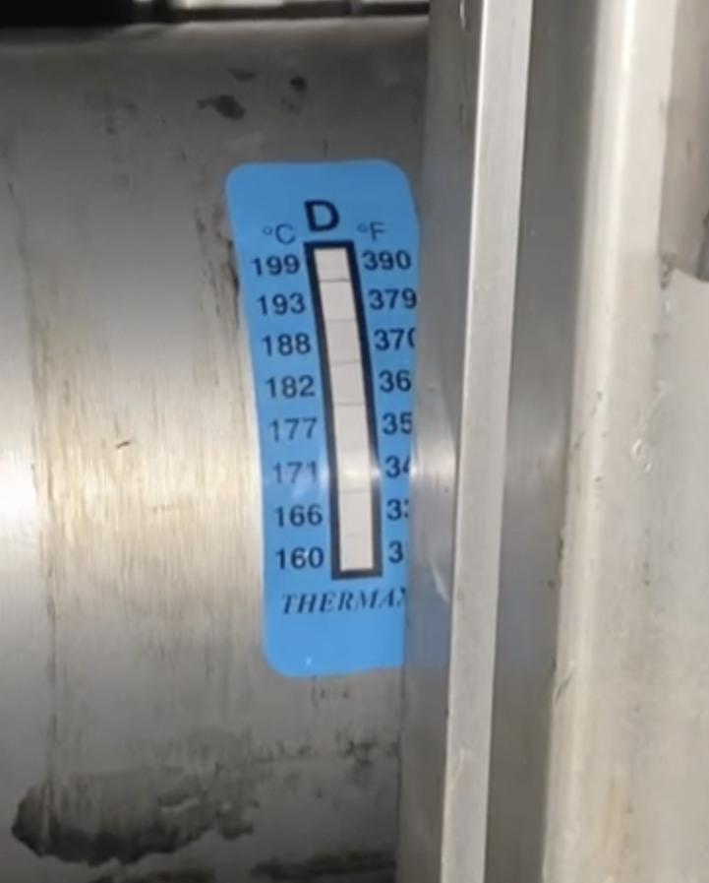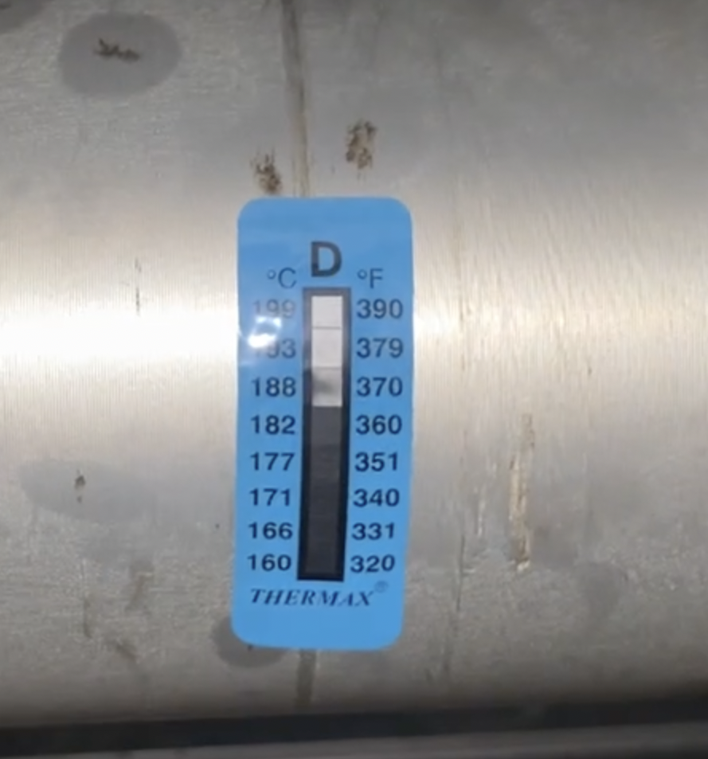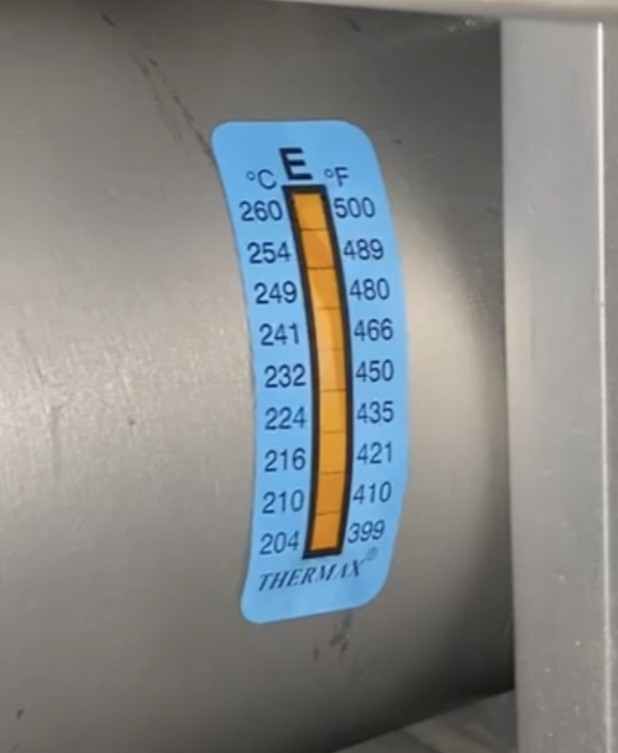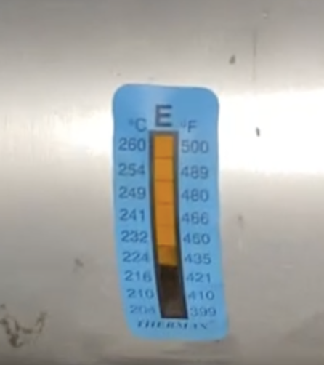

*Temperature strips on the combustion chamber casing, from the injector side (left) to the nozzle side (right), equally spaced*

The middle connector side unscrewed fairly easily after two people held the casing very strongly. The threads seemed perfectly clean. As expected / usual, the injector was covered in soot.

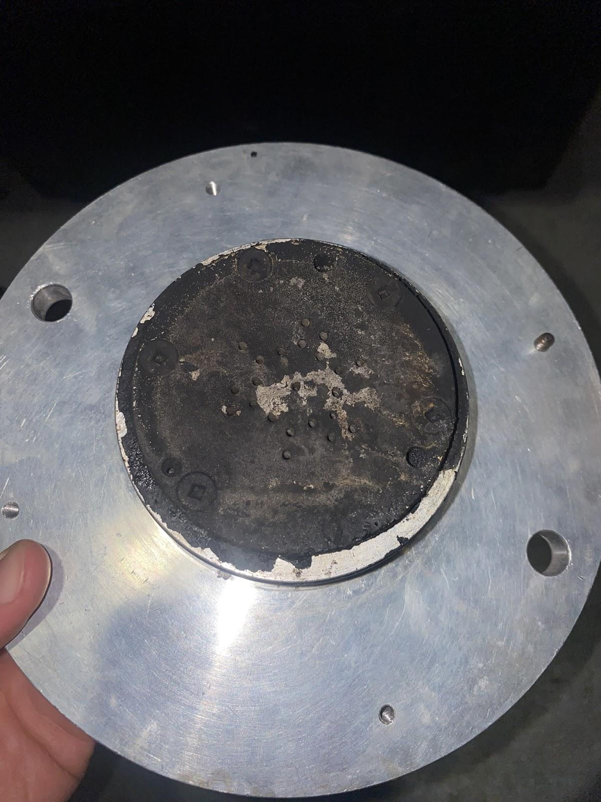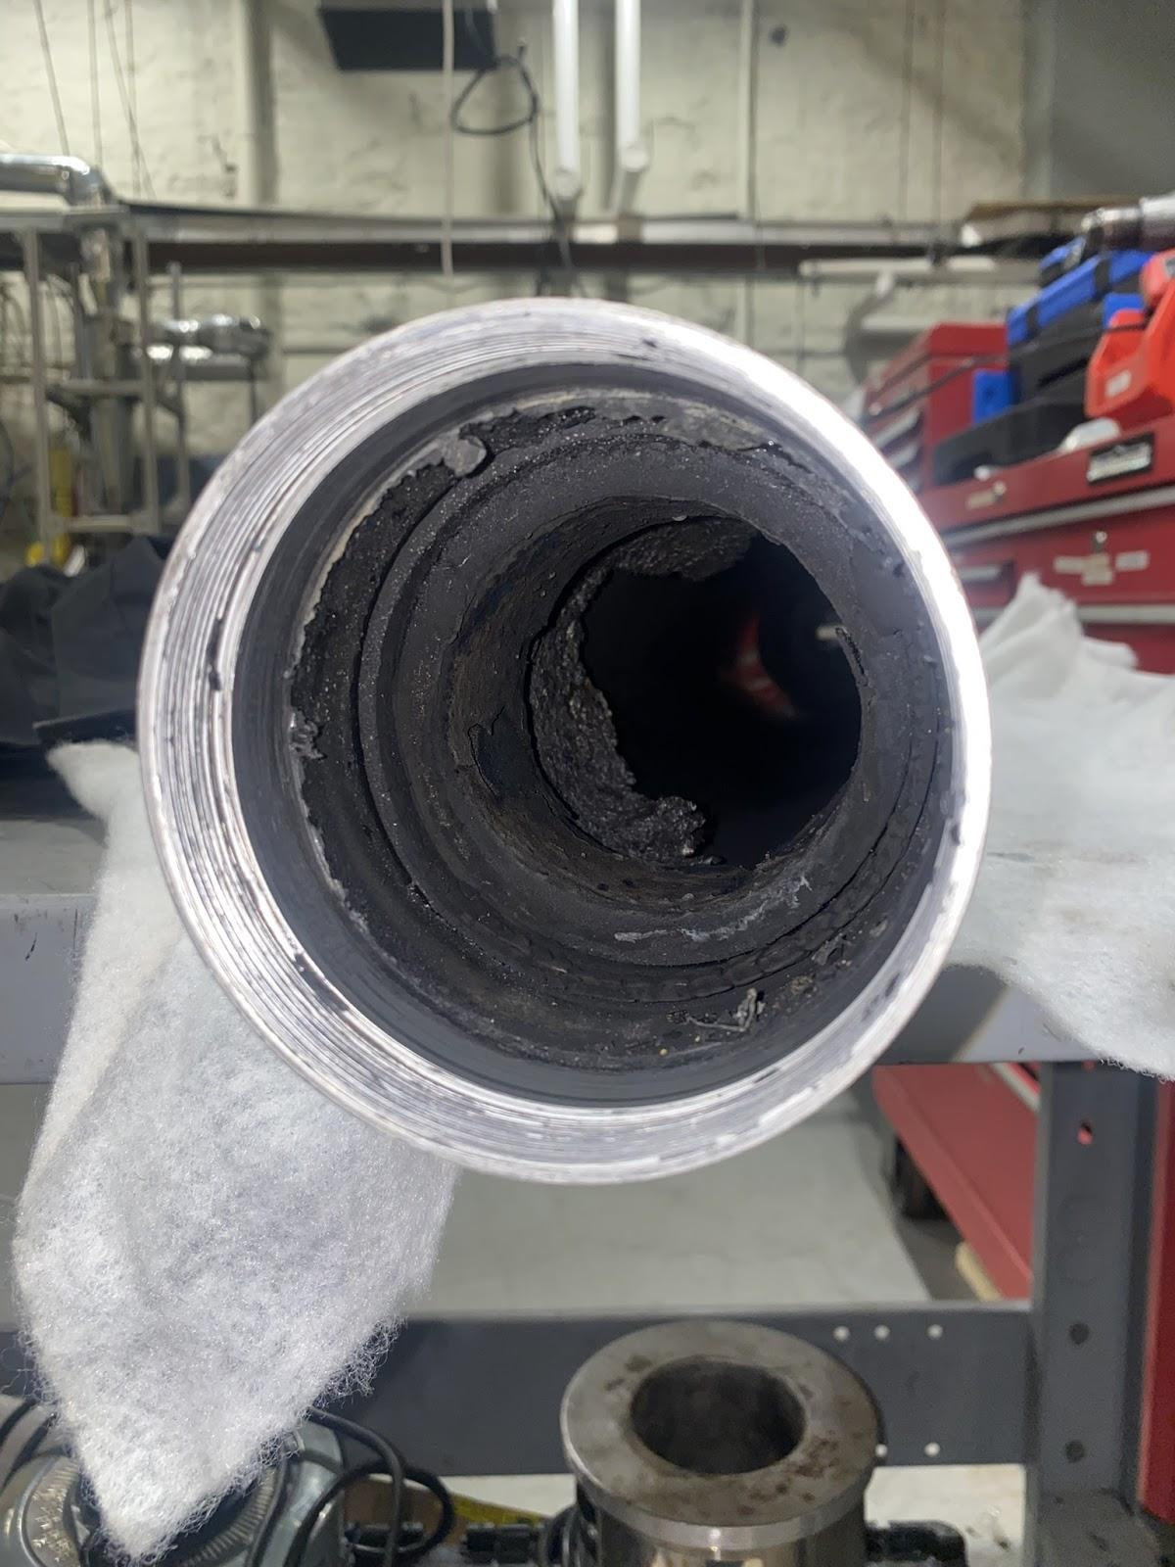

*Middle Connector (injector side), & middle connector side of the casing (open)*

As can be seen above, the top spacer was still holding up: while looking very ablated (as designed), it still retained its shape and a decent amount of thickness, fairly close to its original dimensions. The initial mass was 107 g, and the final mass was 68.749g (35.7% of mass ablation).

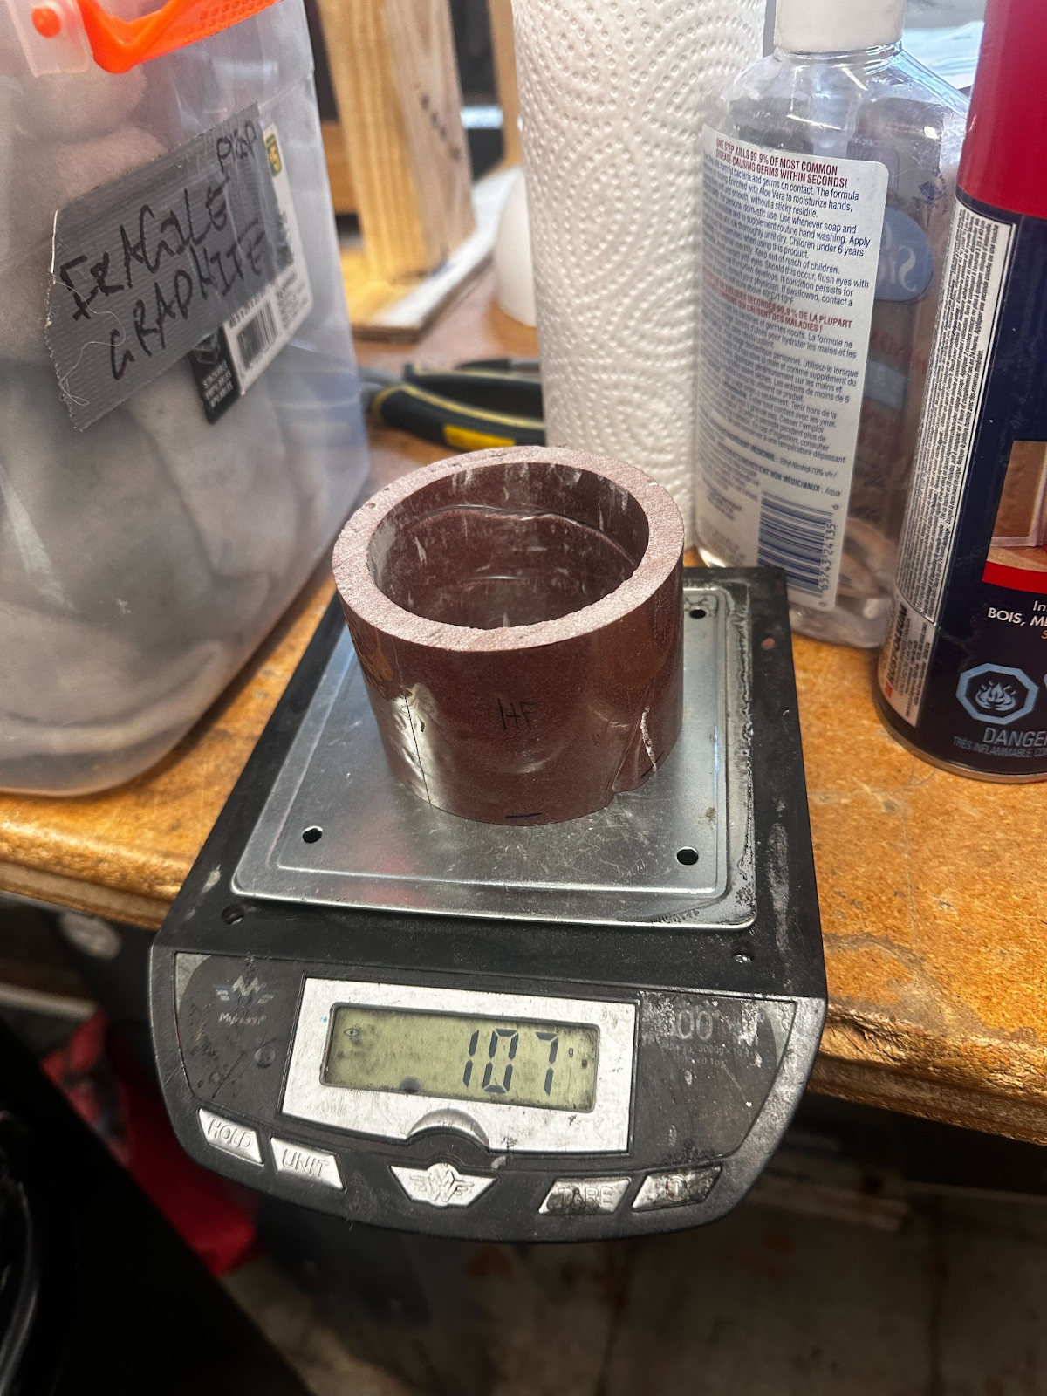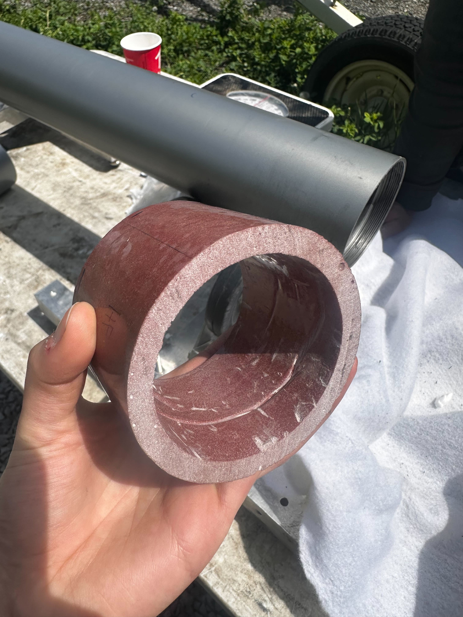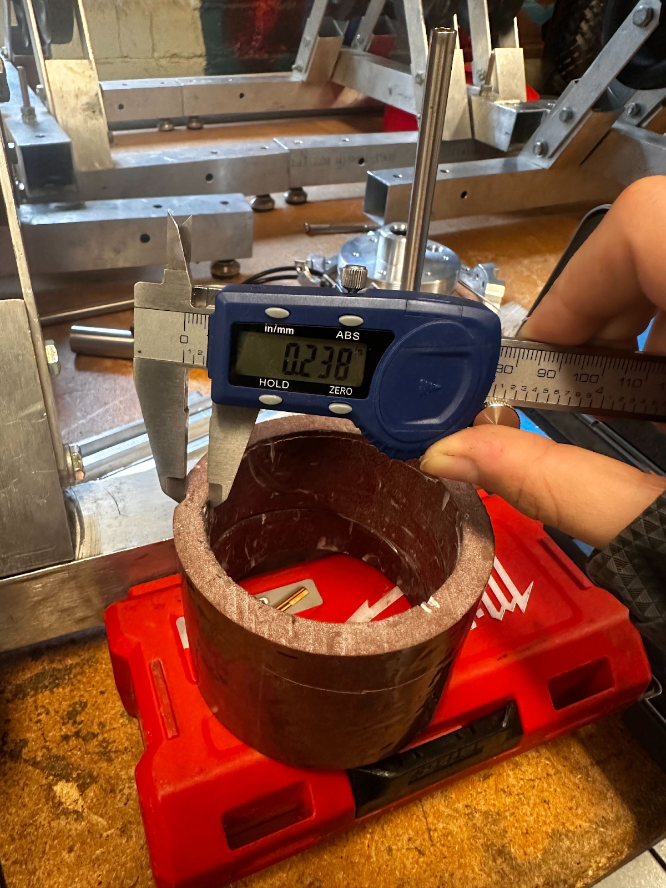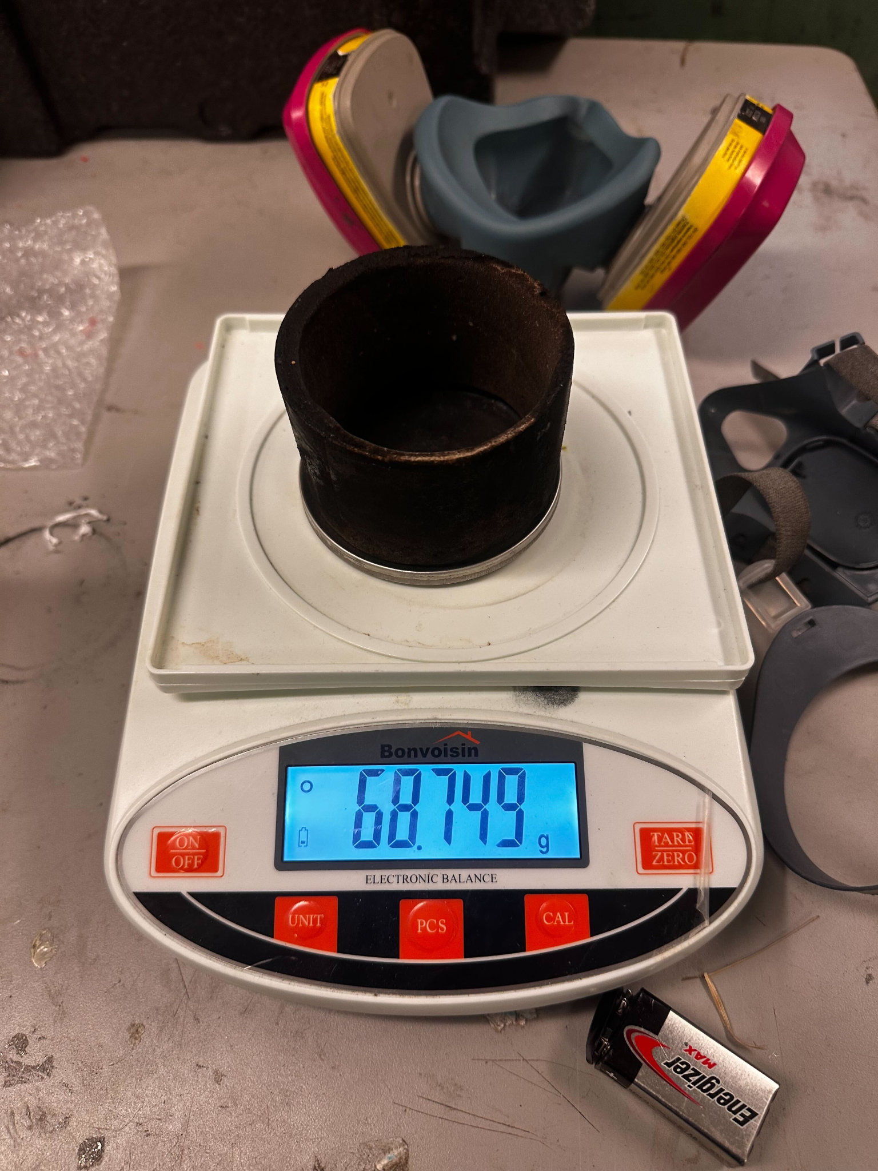

*Top space initial mass (107 g), surface finish, minimal wall thickness (0.238”), final mass (68.749g)*

During removal, small layers fell off from the spacer, which revealed the initial red-ish colour, showing that the inside still had virgin material left (as seen in the images below, on the side view). The spacer did not have through-holes as observed in HF 3.5, and the liner underneath seemed protected: as such, the top spacer is considered to have fulfilled its role successfully.

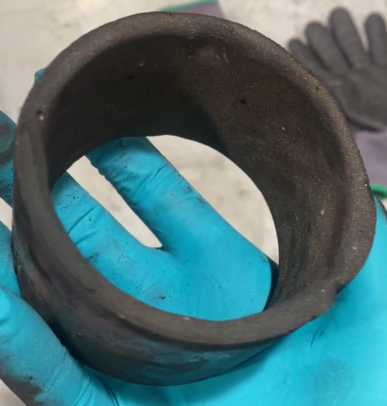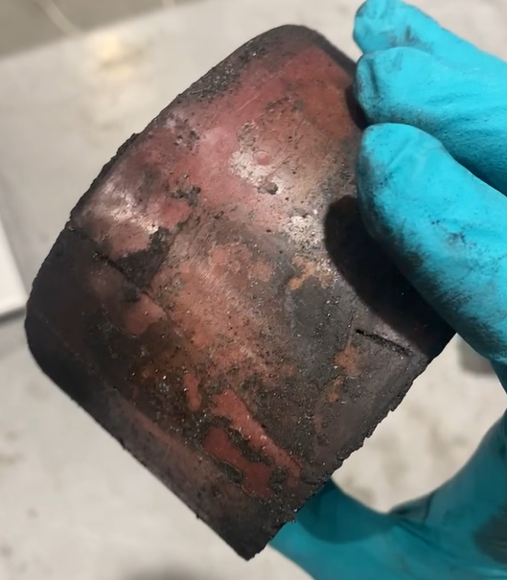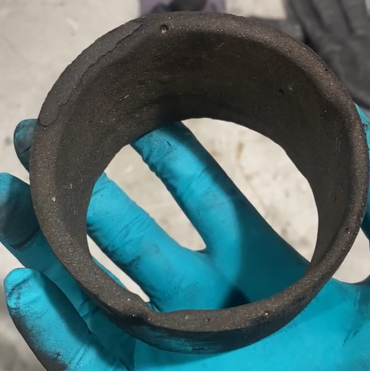

*Top spacer after the burn, top (injector side) view, side view, bottom view*

The liner was still visible under the spacer, and its initial brown colour could still be seen, showing that it had been protected from the intense heat of combustion. However, as can be seen below, the liner seemed completely burned off and flaked right after the top spacer, where the fuel would usually sit.

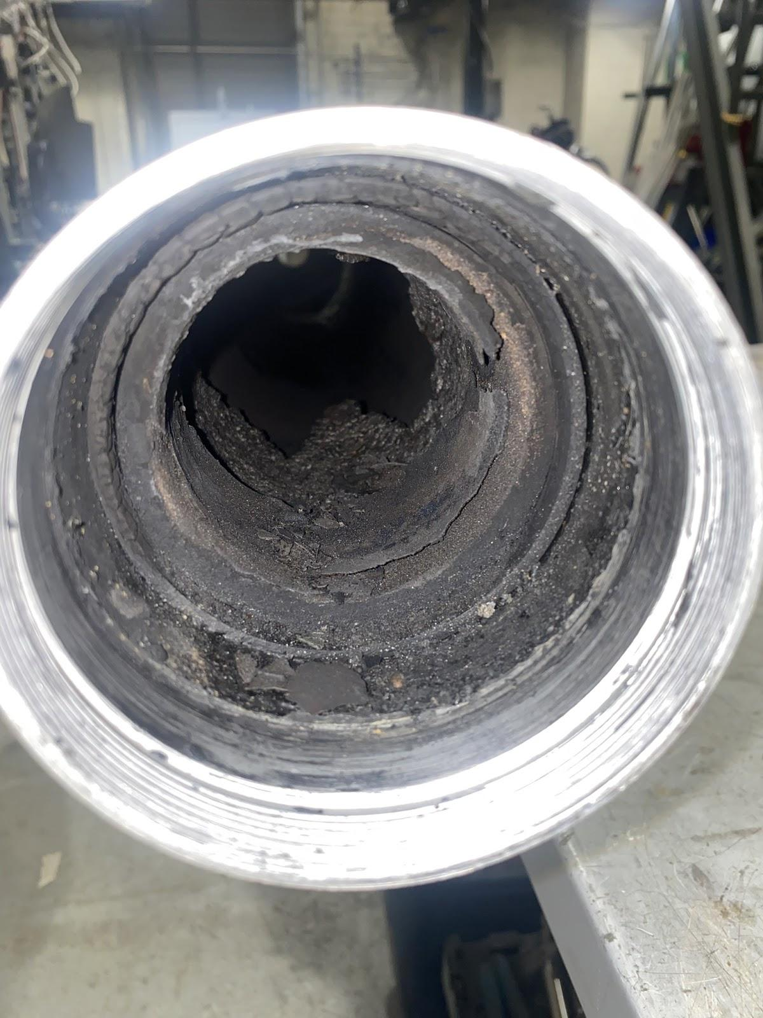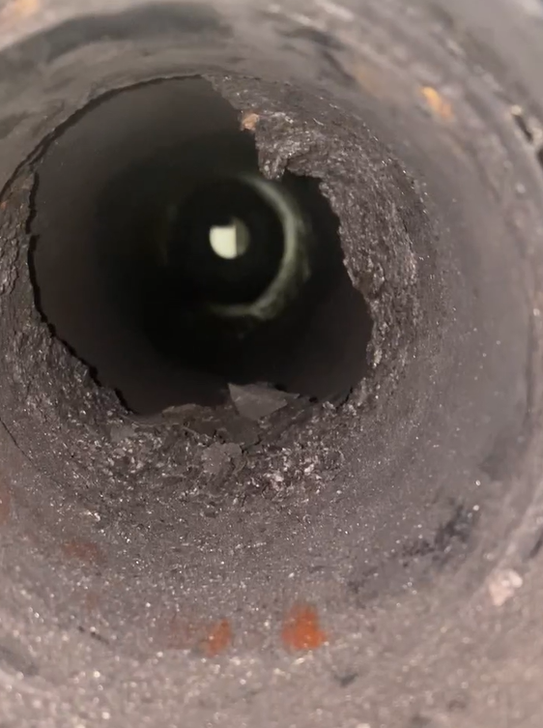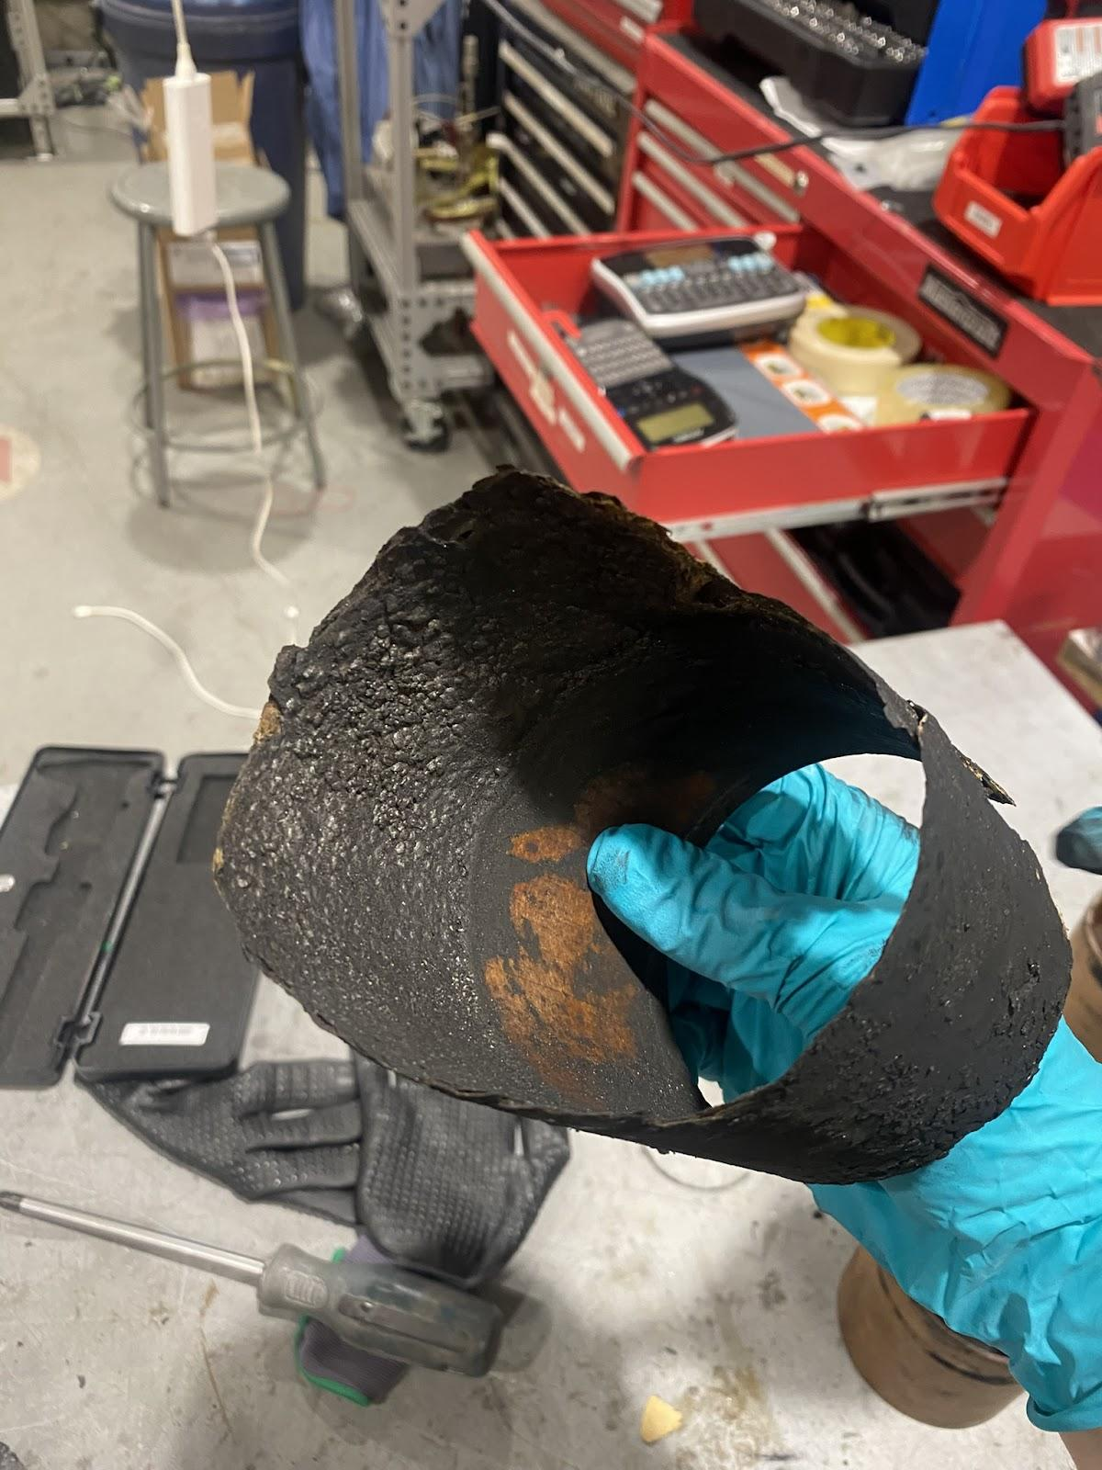

*Top spacer in the casing, remaining liner in the casing, remaining liner once removed from the casing*

The nozzle retainer was more tricky to remove, due to the smaller diameter of the part which made it tricky to apply a large torque. This was solved by putting two screws in a long 80-20 aluminum extrusion, and inserting them inside of the retainer’s slots. With this much longer lever arm and by clamping the casing carefully in a vice, it was possible to un-stuck the part. Once movement was started, it was easy to fully unthread the nozzle retainer by hand. The threads were also very clean.

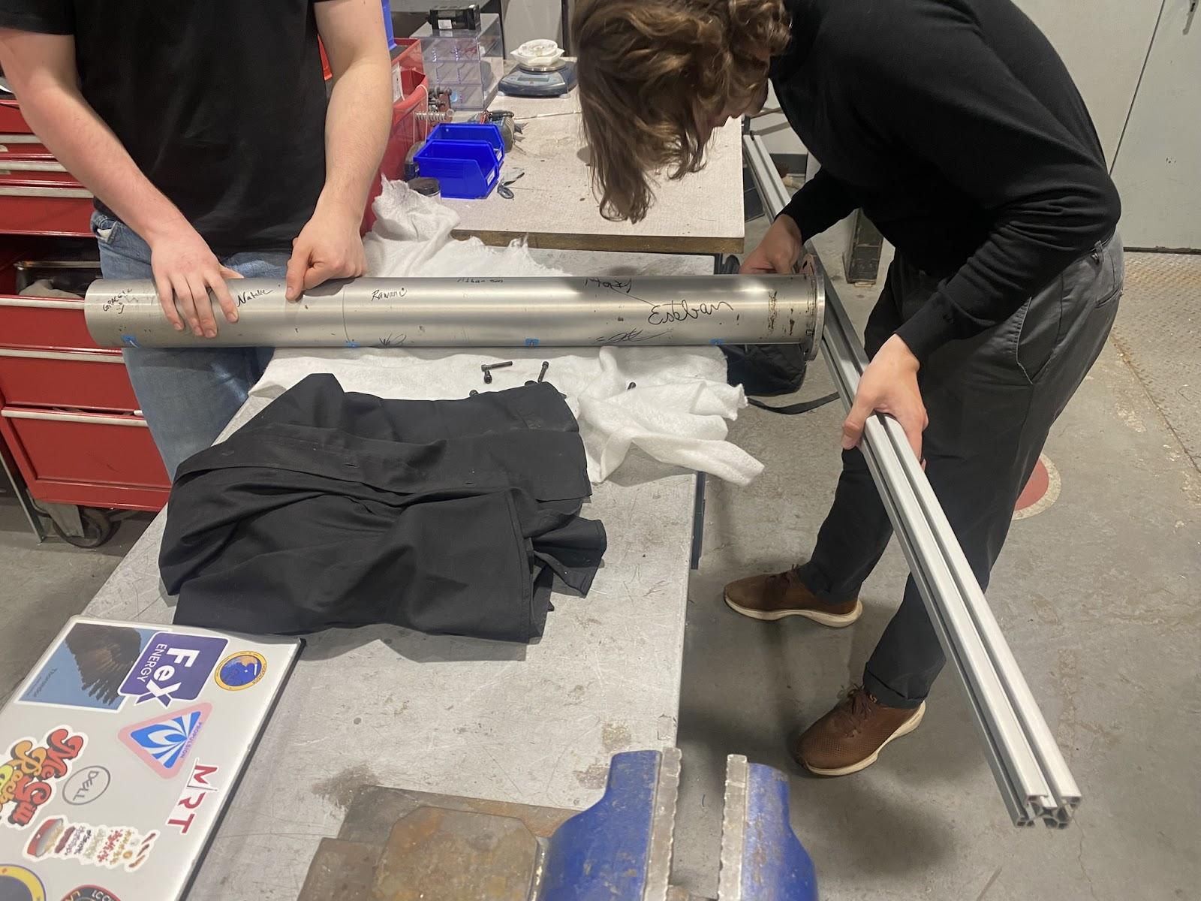

*80-20 extrusion used to increase the torque to unscrew the nozzle retainer from the engine casing*

As usual, the nozzle was stuck inside of the casing. Using the “horses” (hex keys wrapped with padding to grip on to the nozzle’s throat) did not work. It was then tried to push the nozzle out using the other intact liner that was left, by inserting it from the middle connector side. While doing so, it was noticed that the liner could freely slide in the “fuel” section in the casing, showing that the inside was completely “clean” (no liner residue left). Finally, the intact liner started hiding the remaining liner residue close to the nozzle. As pushing it by hand was not successful, the manual press was used along with a holding jig, to precisely push on the liner to get the nozzle out while holding the casing in place.

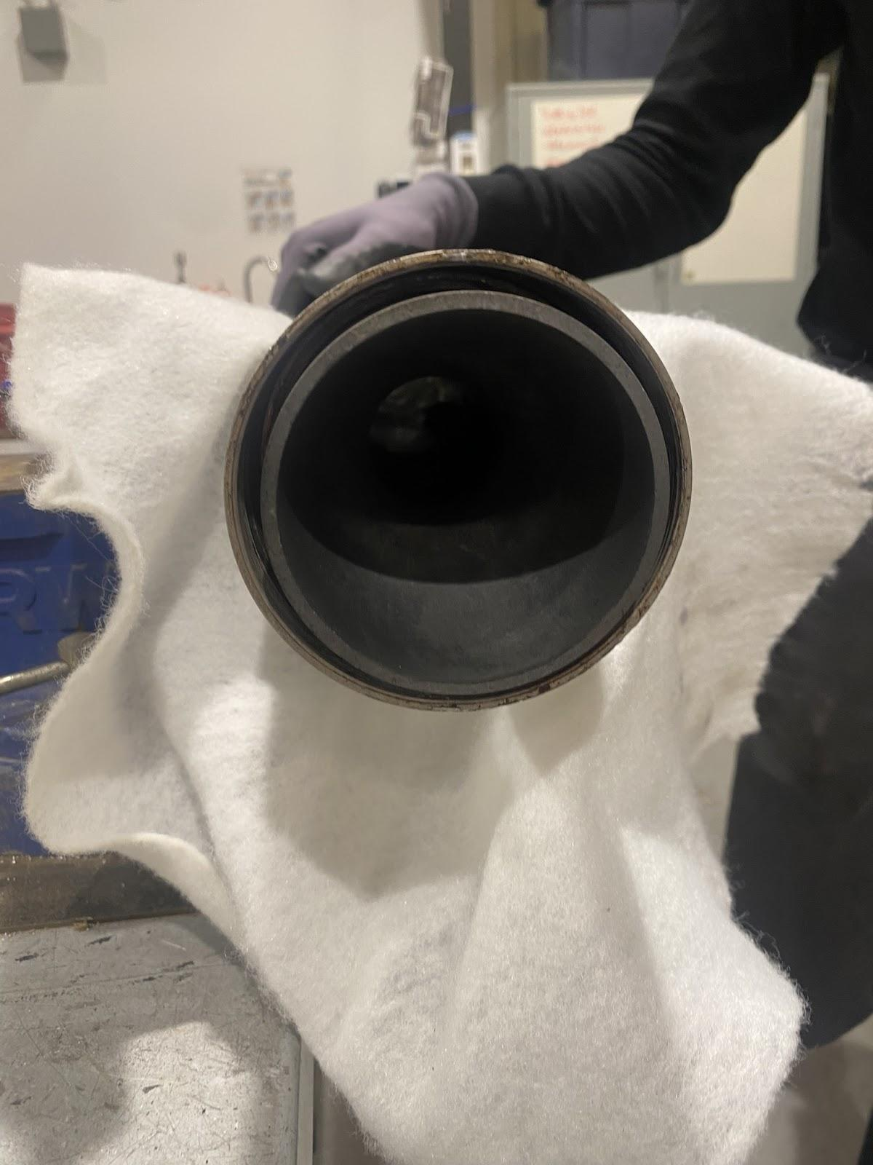

*Nozzle stuck in the casing, nozzle disassembly setup*

Once out, the nozzle was inspected. The o-ring seemed to have permanently flattened (possibly due to the heat), the perfectly clean surface on the nozzle and retaining ring threads indicate that it sealed perfectly. It was also seen that the nozzle had ablated asymmetrically. While it is normal that nozzles ablate slightly after each hotfire, this larger material removal on one third of the entry cone before the throat (identifiable with a much rougher surface texture) is something to be noted down.

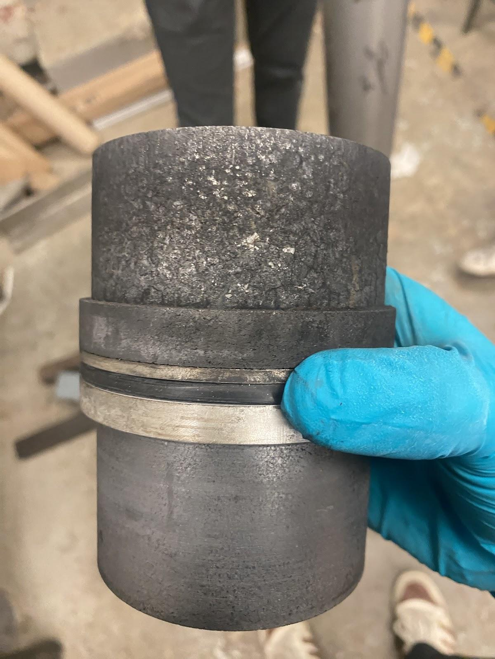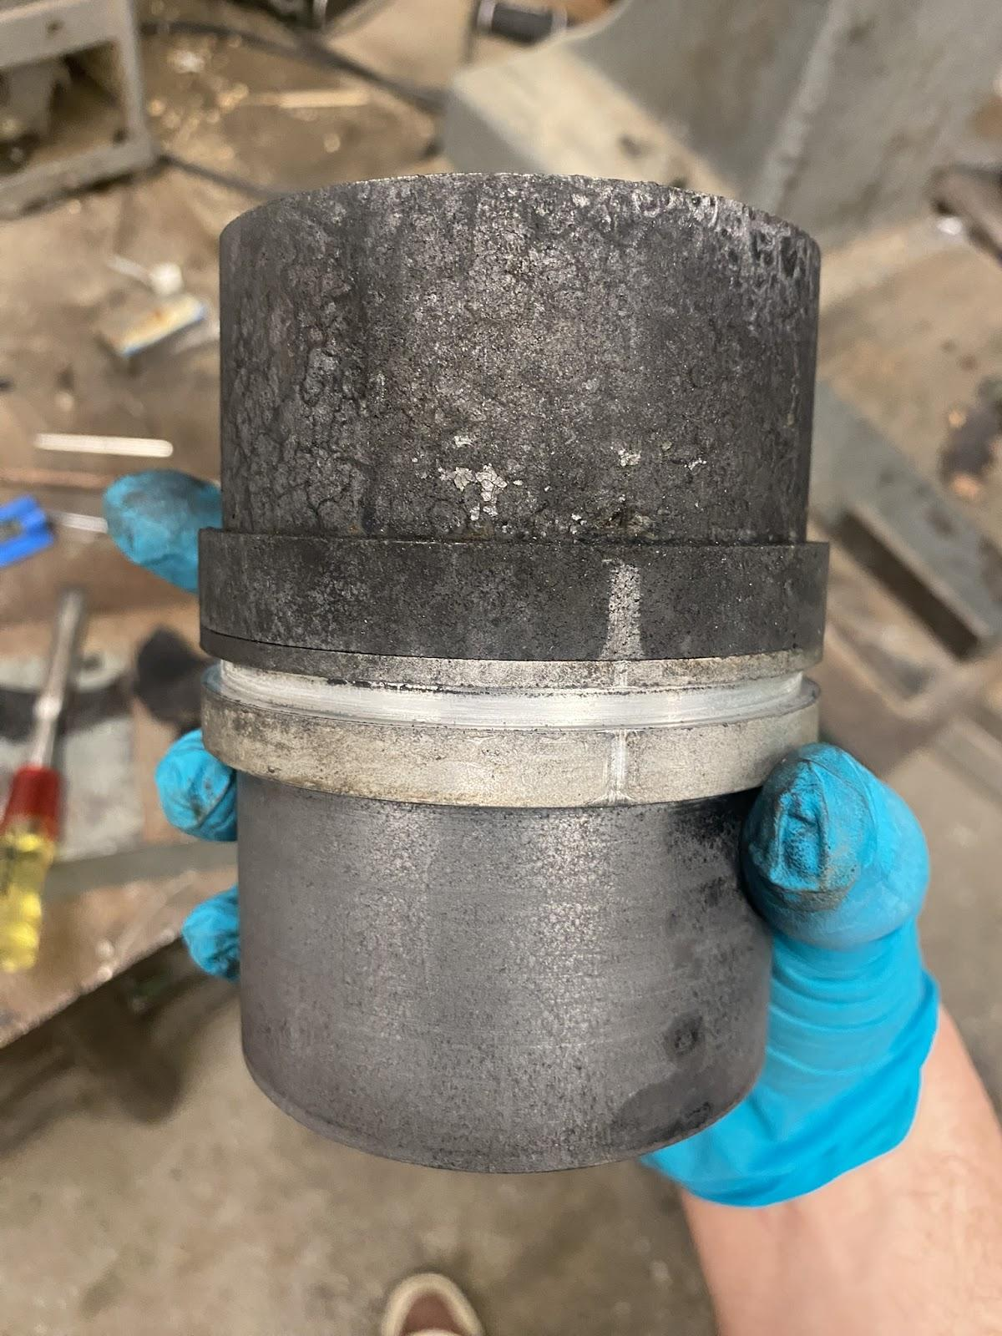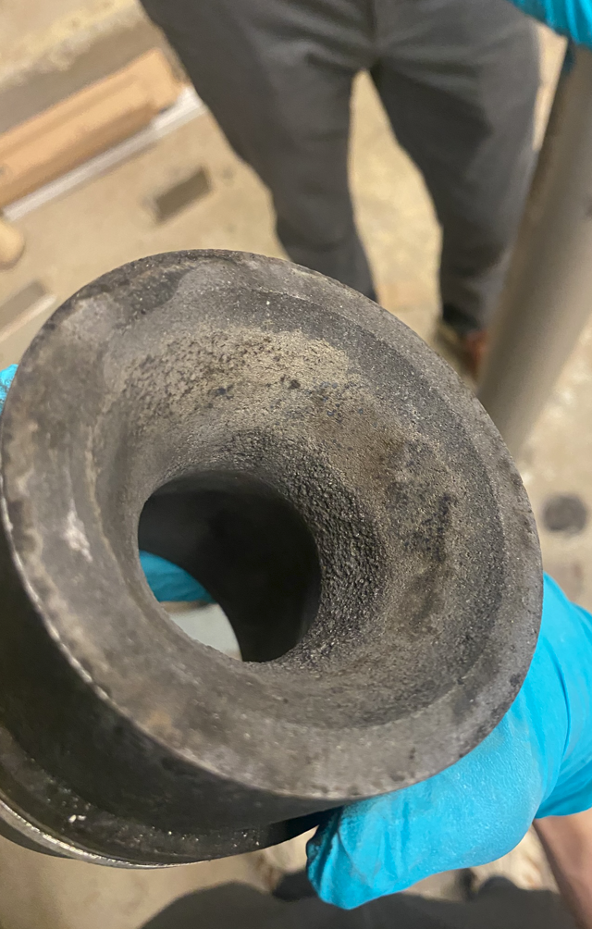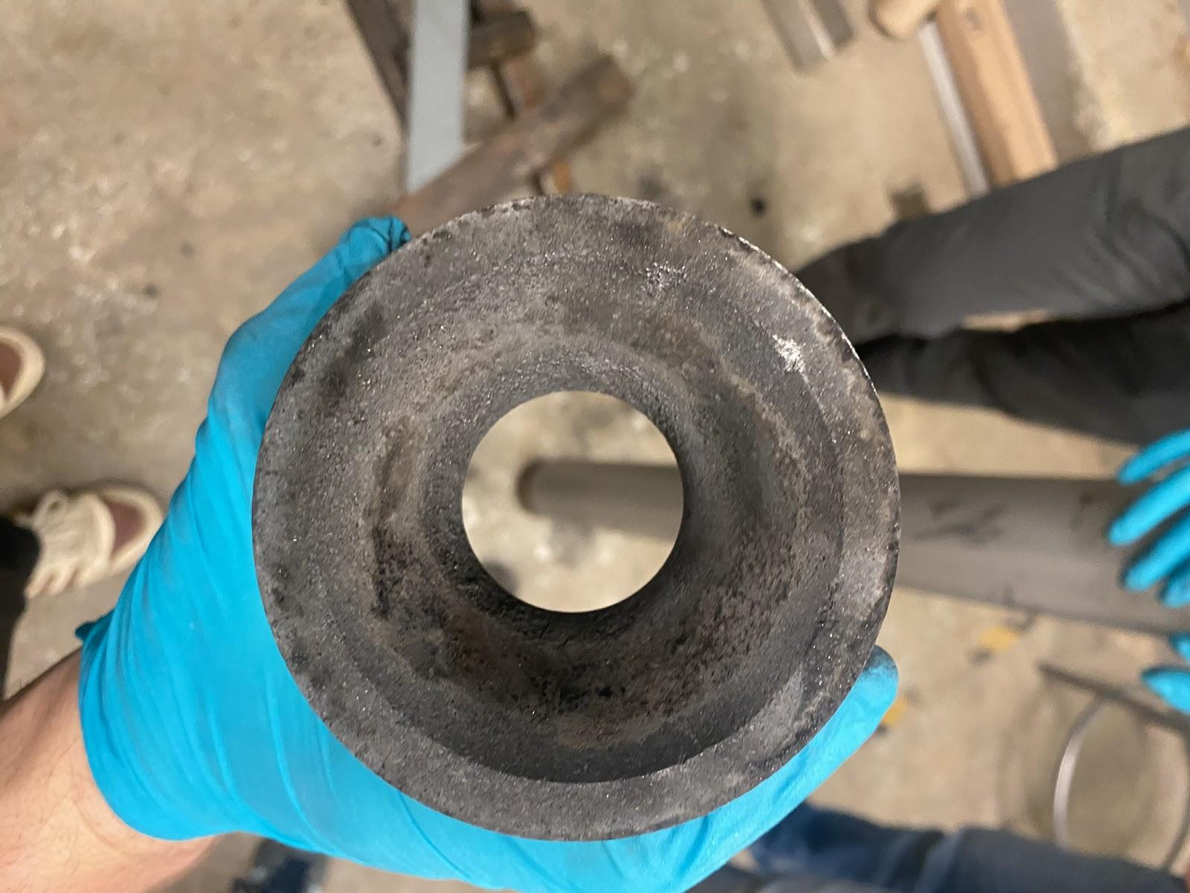

*Nozzle side view (with/without o-ring) & nozzle throat inspection*

Once the nozzle was removed, it could be seen that a section of liner had survived at the supposed location of the rear spacer.

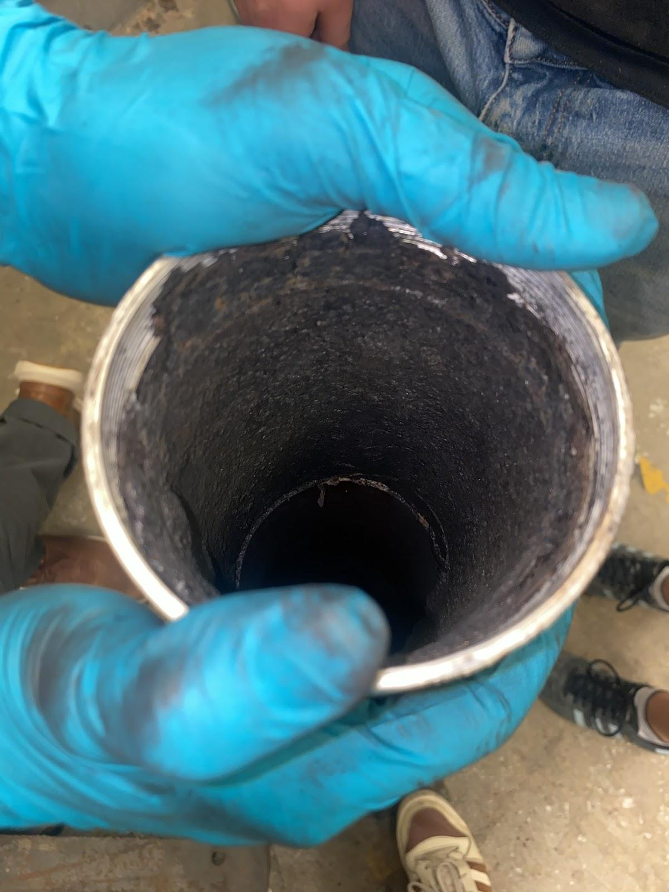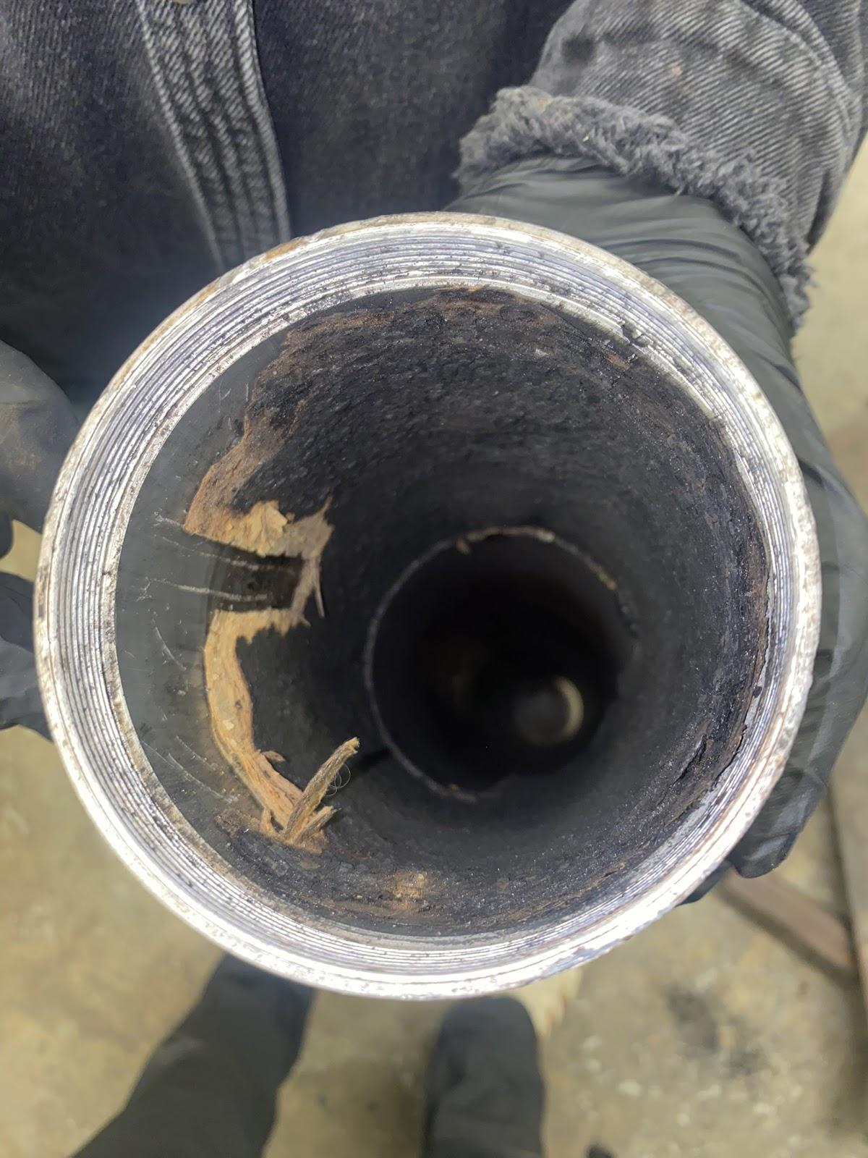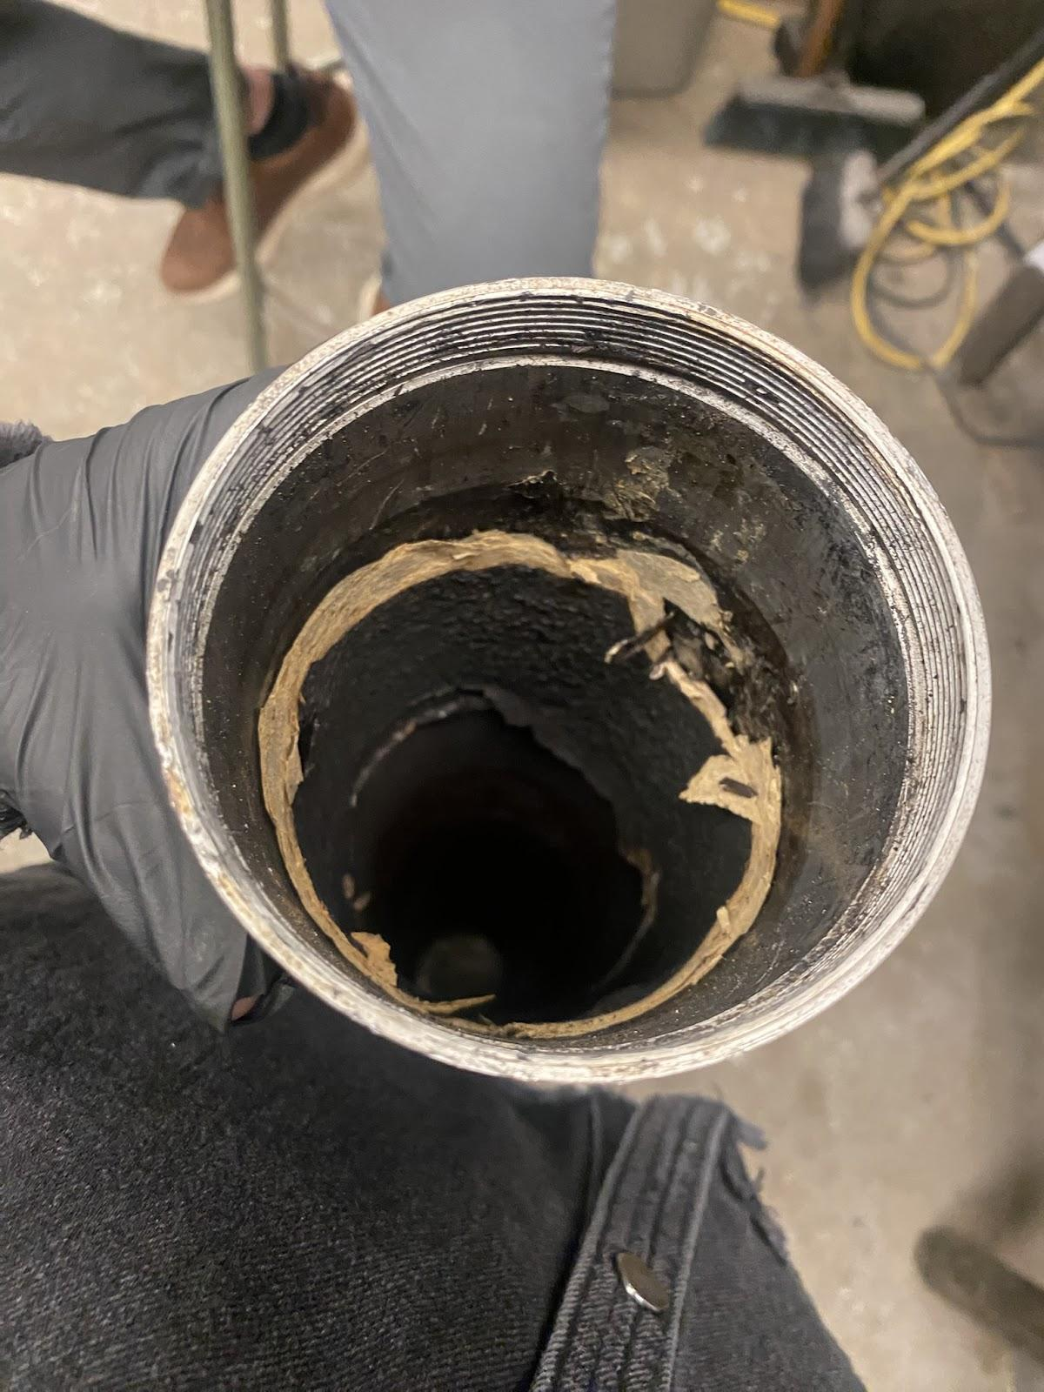

*Remaining liner on the nozzle side (as found, and then chopped using a screwdriver)*

Removing that liner using a screwdriver revealed the typical beige colour of the virgin material, indicating that only the top surface had charred.

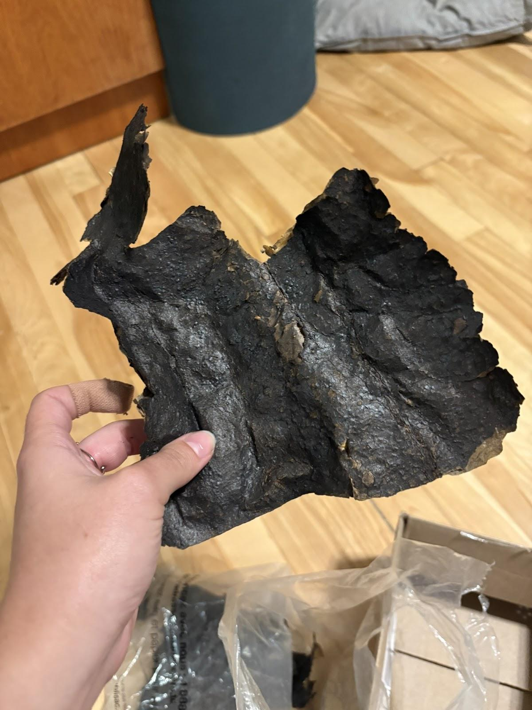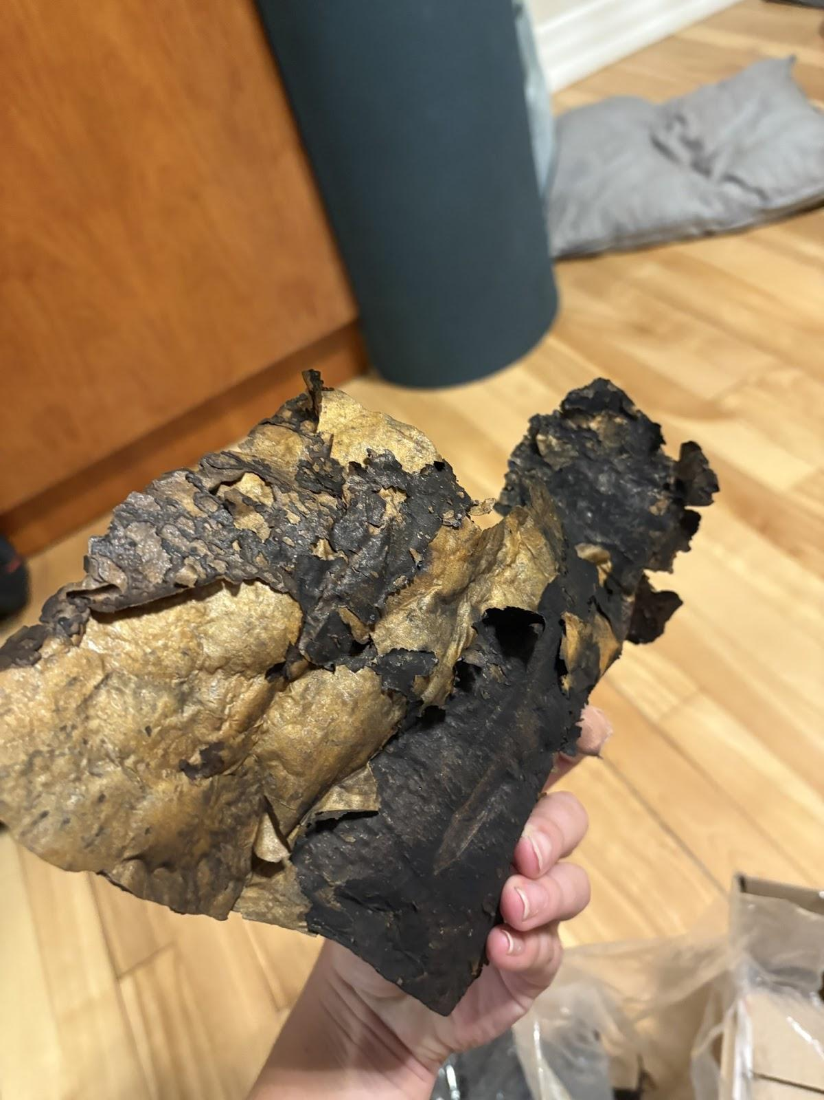

*Liner fragments found on the ground at the test site*

During the teardown at the testsite post hotfire, fragments were found on the gravel directly in the line of the firing engine, as can be seen above. The position of these fragments were later correlated to debris seen to be shot out of the engine during the later portion of the test, visible in the drone footage accessible below. They are seen to be on fire, and are still glowing after the test is completed. Upon further analysis, these fragments were found to be partts of the liner, seemingly sheared off the interior of the liner section by section. The left picture shows the charred side of the liner, while the virgin color of the liner material can be seen to the right, with significant material expansion.

**Video footage:**

Videos taken from multiple angles give further information on how the hotfire proceeded.

[HF4.1_drone_sound.mov](https://drive.google.com/file/d/1u_l1c7W-cw3uRFe1tSGo93FmixyzDLUJ/view?usp=drive_link)

[MRT_Hotfire_4.1_original.mov](https://drive.google.com/file/d/1G4A3dOrPoIi0BQ9xbtIWmk6RB16clWje/view?usp=drive_link)

[Hotfire_4.1_OBS_Screen_Recording.mkv](https://drive.google.com/file/d/1UHUnxCJvaXSdsGtciTkB4A2Hpn92sqes/view?usp=drive_link)

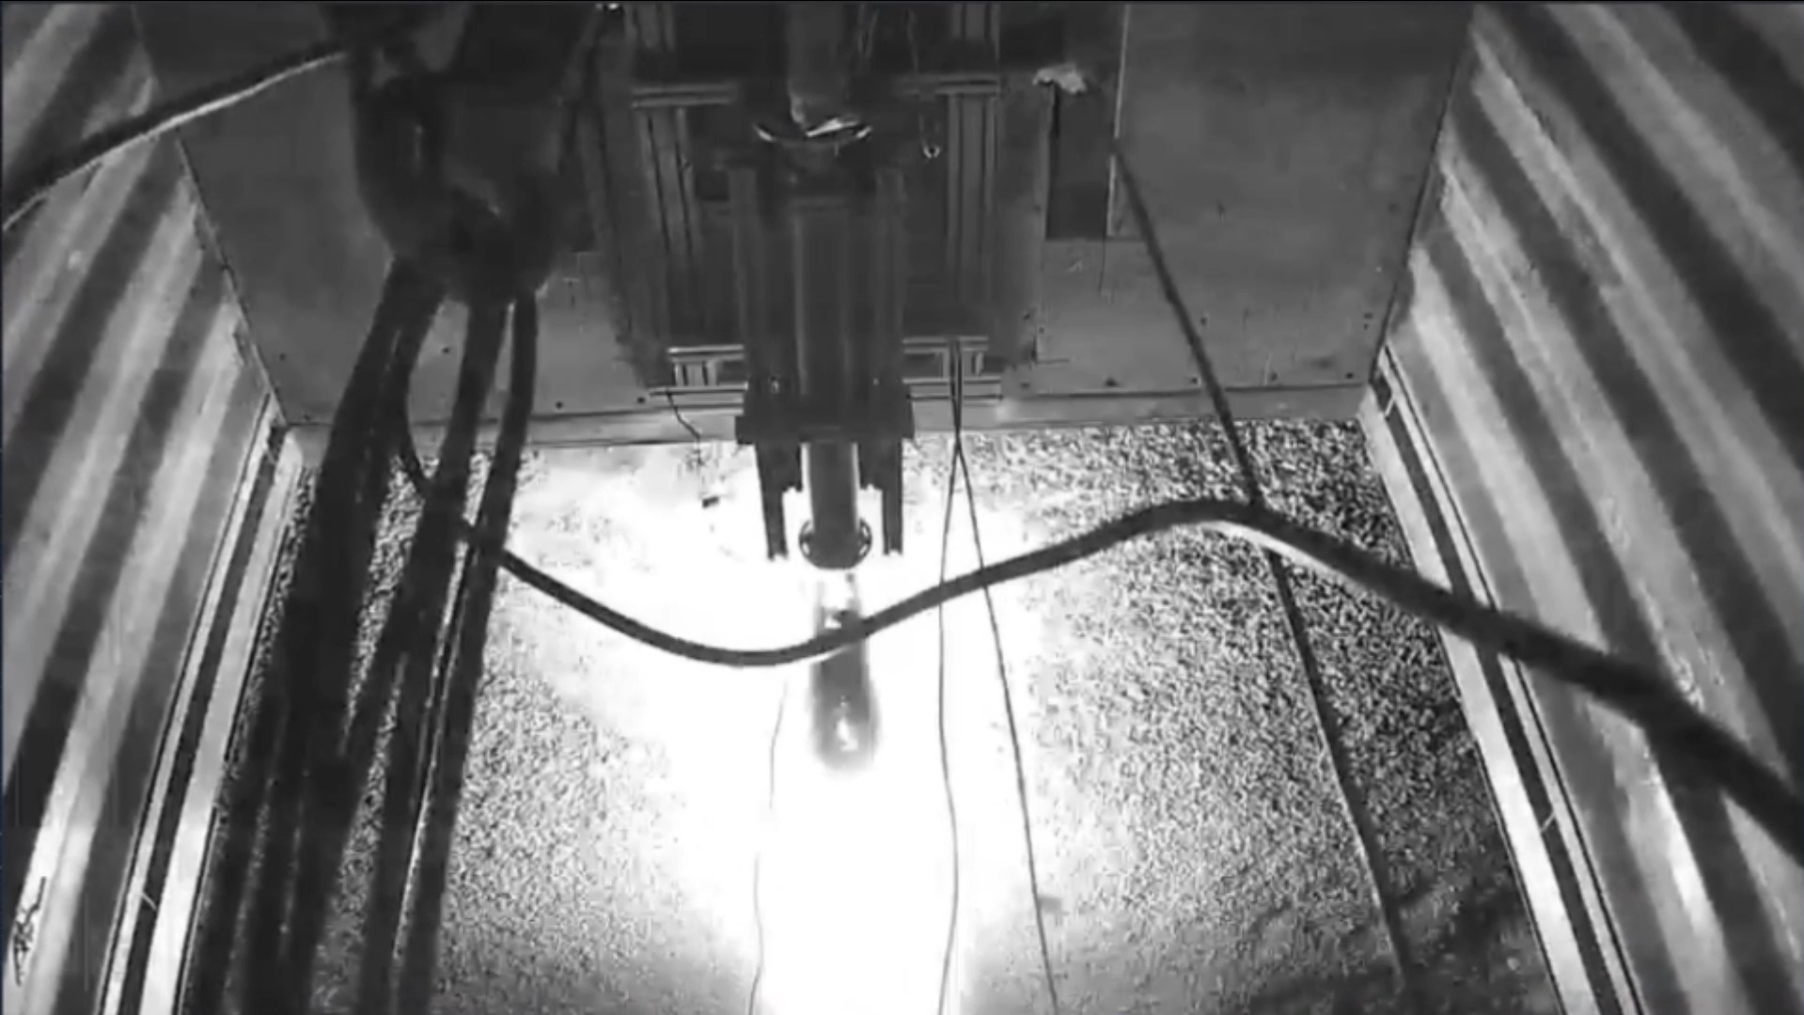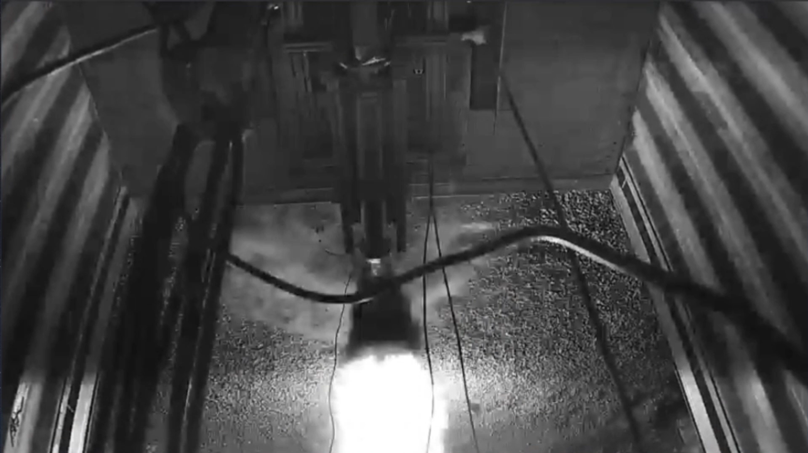

*From the Security Camera footage, ~4s into the burn*

Seen by the Ubiquity security camera (in black & white as it hadn’t switched back from the IR night vision yet), it appears like an object flew out of the combustion chamber, about 4 seconds into the burn.

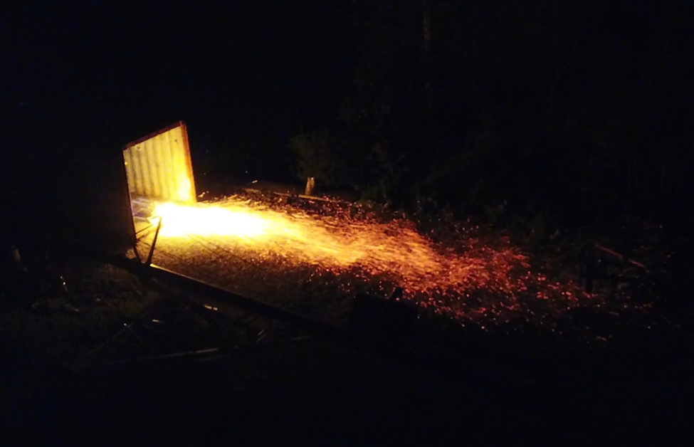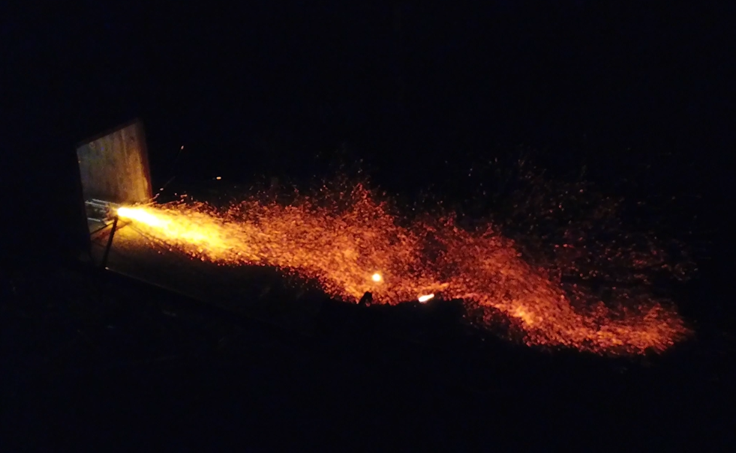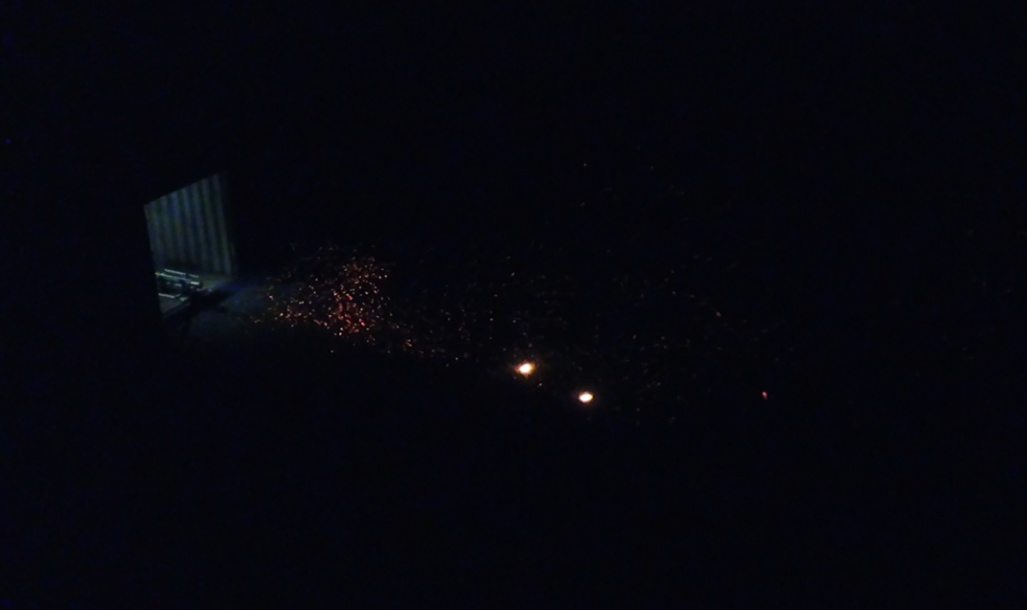

*Drone recording, 15, 17 and 20 seconds into the burn*

The end of the burn (starting at around 13 seconds into the burn) features a very sparky and turbulent flame, which could come from the fuel grain being completely depleted and the liner burning directly. The fragments of liner mentioned above can be seen glowing in the picture to the right.

**Possibilities:**

Both constant thrust and combustion chamber pressure curves are noticed in the first 4 seconds of the burn. Previous engine tests have shown quite different thrust profiles, in which a peak thrust is achieved and decreases significantly at the beginning of the burn (e.g. [Hotfire 3.4](https://drive.google.com/drive/folders/1GCohKqk0dyEOPdwrluoBCkcadl8OhY-V?usp=drive_link)). The combustion pressure profile also shows an identical shape to that of the thrust graph. As with thrust, nominal tests demonstrate a sharp increase in combustion chamber pressure followed by a rapid decrease into the typical slope of a liquid blowdown.

Constant combustion chamber pressure would theoretically be possible if the effective nozzle throat was much smaller than the intended throat area. It was first hypothesized that the nozzle throat diameter had either been designed incorrectly, or machined too small. This hypothesis was dispelled by comparing both nozzle throat and exit areas to those from the conical nozzle using in Hotfire 3.4, with minimal differences found. Upon disassembly, the nozzle throat diameter was found to be slightly larger than designed, most likely due to ablation during the burn.

A smaller effective nozzle area is also possible if the throat was somehow clogged by debris. As the front spacer was inspected to be fully intact, it is unlikely that this would be the cause of the debris. The rear spacer was not present at the time of disassembly, so it is possible that a piece of the rear spacer broke off and got dislodged into the nozzle. This spacer failure would have then caused an accelerated breakdown of the rest of the spacer. However, it is unlikely that the entire spacer failed right away, as there was still liner intact where the rear spacer is placed. The reading of the temperature strip placed at that location was also not activated, supporting the hypothesis that the spacer did not completely fail at the beginning of the test.

A piece of the fuel could also be the culprit of the nozzle blockage. Due to less than ideal spincasting malfunctions, the fuel was left with a small conical section at the leading edge. This engine test used a different igniter than tests in previous years, which was deemed to be more powerful than those used in previous years. It is possible that the impact of the ignition sequence broke off a section of the fuel, which then clogged the nozzle.   
The second large thrust and combustion chamber pressure spike at the end of the plateau can be related to the moment in the video footage in which it is apparent that there is debris shot out of the nozzle. The following thrust curve resembles a nominal liquid blowdown, which would suggest that the debris was dislodged and the nozzle could function as expected. This supports the hypothesis that the high and constant combustion chamber pressure was due to a nozzle blockage.

| **Component** | **Change VS previously tested configuration** | **Potential impact** |
| --- | --- | --- |
| Middle connector | No change | NA |
| Injector | No change, same 22 hole injector as used in HF 3.4 | Expecting similar pressure drop value (~200 psi) for a CC pressure of 580 psi |
| Liner | No change, same paper phenolic as before | NA |
| Composite spacers (pre & post) | Only the rear spacer had been tested on HF 3.5, on a shorter burn with lower CC pressure | Mechanical failure of the spacers would have an impact on the test |
| Fuel grain | Lower fuel grain mass than target (but the engine was previously tested with similar fuel mass) | Lower total impulse |
| Nozzle | New parabolic nozzle (new geometry, similar throat area), made out of graphite | Slightly higher thrust than with previous nozzle (~1%) |
| Igniter | New solid rocket motor used to make the igniter (Aerotech G75J-10A, instead of the previously used G69-14A Pro38) | Different smoke (expected to be thicker and more black), lower chance of misfire, more fuel grain erosion before running |

*All engine components and their changes with respect to previously tested configurations*

| **Parameters** | **Aerotech G75J-10A (new motor)** | **CTI G69-14A Pro38 (old)** |
| --- | --- | --- |
| Total Impulse | 155 N.sec | 117.15 N.sec |
| Peak Thrust | 76 N | 91.97 N |
| Burn Time | 2 sec | 1.84 sec |
| Propellant weight | 106 g | 67 g |

*Comparison between new and old solid motors used to make igniters*

A new igniter solid motor was sourced due to the lack of availability of the original one (see the following comparison document that justifies the choice: [Igniter comparison list](https://docs.google.com/document/d/1iHPOTZ56acO5Y9K_xdwByPVHXbyGz449vyHLKgs9vTo/edit?tab=t.0)). While traditionally only half of a solid motor is used to make the igniter, the first time an igniter was made using the new motor, it was decided to use a full one (two halves) due to the smaller physical size and shorter burn time. This resulted in having an ignition power of more than 2.6 times the usual level (which could also explain why the smoke was so easily seen from the cameras).

Additionally, due to the ignition issue at the Launch Canada 2024 competition, the wait time after ignition was increased to 5 seconds once smoke was seen. Moreover, the fuel grain was quite thin, due to its lower mass caused by the leaks in the spincaster.

Thus, it is actually very likely that the fuel got melted much more than desirable, and thus might have cracked it and/or the excess liquid blocked the nozzle. This could also explain how the nozzle would have gotten partially clogged immediately (VS the spacer, which would have had a nominal burn at least for the first few milliseconds).

**Mitigation strategies**

* The composite spacers should be more thoroughly tested before being tested in a hotfire again. More specifically, their mechanical properties and resistance to heat should be better characterized. Additionally, it should be verified whether the manufacturing method is capable of producing nearly identical quality-products on every batch, as concerns were raised regarding the use of microbaloons (which could easily accumulate heterogenously). Additionally, concerns were raised regarding the latter ingredient over their such minuscule size, which might not benefit heat-dissipation as much as previously thought.   
  Overall, the mechanical resistance of the spacers should be better characterized (axial compression, radial pressure…) and their heat resistance should be further tested (for example, by firing igniters in them).
* The impact of the new igniter motor material should be better understood. While these did provide much better (thicker) smoke at ignition, their higher power could also have been a source of issues, for instance by melting too much fuel before running, which could have resulted in a mechanical failure of the grain (pieces detaching and partially clogging the nozzle).   
  For instance, the melting-ability of the igniter should be compared to the previous one (lighting an igniter on top of a fuel grain).  
  Additionally, the impact of the igniter on the pre-combustion chamber spacer should also be quantified, to understand if that could have lead to an early liner failure by propagating more easily through the composite material than through the graphite.

**Procedural issues:**

* Neither OP1, OP2, FP, and an additional person could open the flipped nitrous bottle’s needle valve. The TD came and opened it, by first slightly loosening it wearing a regular rubber-coated glove, and then fully unscrewing it wearing cryo gloves.
* Two road blockades came back to the control station immediately after the hotfire was done, without being instructed to do so. They were immediately instructed to go back, as the system had not yet been fully safed.
* The TD should have pressed the e-stop upon seeing the curves on the user interface. This was not done because of the stress of the test, lots of data to look at the same time, and lack of past experience directing a test.

Overall, running through filling & heating procedures was very quick and with little issues to be noted down.

**Conclusions:**

* As the target fuel grain mass was not achieved, the total propellant mass was under the target, and thus a new thrust curve could not be produced for Thorondor Mk.IV’s flight (for LC 2025). Thus, the engine shall revert back to the Maelstrom Mk.III parameters.
* Taking into account the lower propellant mass, the performance of the engine was much lower than expected, with a peak thrust of 1.356 kN and a total impulse of 12.414 kN.s (compared to HF 3.4’s 6.204 kN peak thrust and 28.583 kN.s total impulse).
* The burn was not nominal, and after disassembling the engine, the performance of the composite spacers has been put into question. While the complete absence of a rear spacer is worrisome and should be investigated, the top spacer’s results seem promising. However, the composite spacers should require further testing before being used for flight.
* The running theory to explain this off-nominal burn is that the
* Further testing of the fuel grain, composite spacer, and igniter should be run to help prevent such issues from happening again.
* Better safety mechanisms should be implemented. For instance, exact cutoff values for pressing the emergency stop button (eg: CC pressure of 650 psi and over) should be written down in procedures, and a red cutoff line should be implemented on the user interface to help the TD to see if that threshold is surpassed. Additionally, a software emergency stop should be implemented as well, for example if the CC pressure is above an even higher threshold (700 psi for more than 0.1 seconds, and injector delta P less than 50 for more than 0.3 seconds - to avoid dumping in case of noisy data) in order to ensure the system will always stay within a safe range, even if the TD fails to see it.
* Operational readiness of competition personnel was validated.

Final conclusion: Maelstrom Mk.IV was not validated for flight, and due to a lack of time to test it again, the LC 2025 engine will be fully switched back to the Maelstrom Mk.III configuration (graphite pre & post spacers, conical nozzle, spincasted fuel, previous igniter).